**Topics Covered  
Topic**: JSX Explained

**Topic**: GitHub

**Tip**: PROJECT LOCATIONS

**Topic**: REACT HOOKS & REDUX

**Topic**: REACT PAGE LAYOUT

**Topic**: DEPLOYMEMT

**Topic**(s): HELPER – TROUBLESHOOTING TOPICS

**Topic**: REACT FINDINGS – CONCEPTS

**Topic**: HELPER SECTION

**Topic**: REFERNCE INFO

**Topic**: Passing data between Parent and Child

**Topic**: Installing MYSQL on Mac

**Topic**: Controlled Form Example (With Bootstrap Styling)  
**Topic**: Controlled Form using an object with UseState  
**Topic**: Error with Form.Select with Webpack  
**Topic**: Building a complex form with useState Object

**Topic**: JSX Explained

When you create a pure function in your react project:  
You have one main exportable function  
**You create functions “within” your main function**

One of the best articles I have read on React for explaining functions, classes concepts etc.  
https://www.freecodecamp.org/news/react-components-jsx-props-for-beginners/

Highlights:  
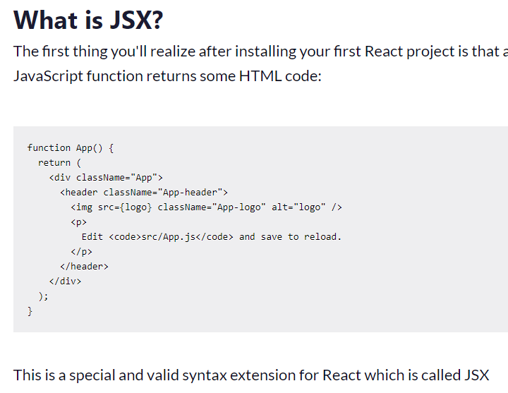  
  
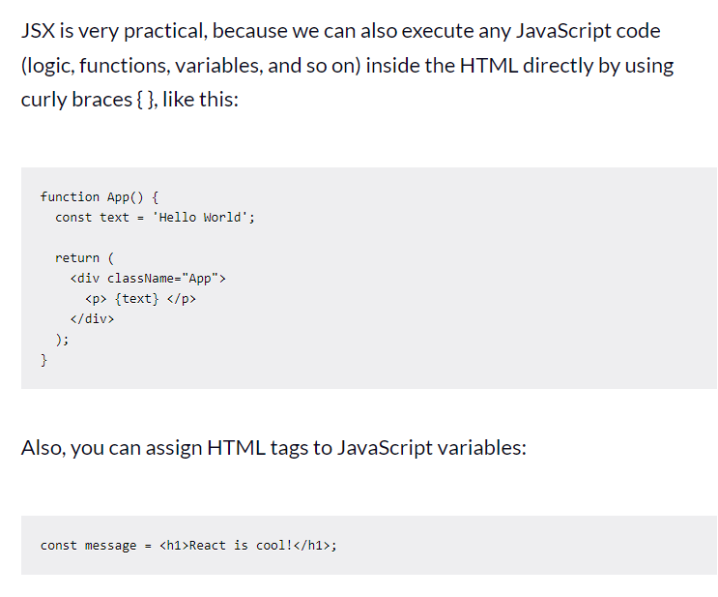

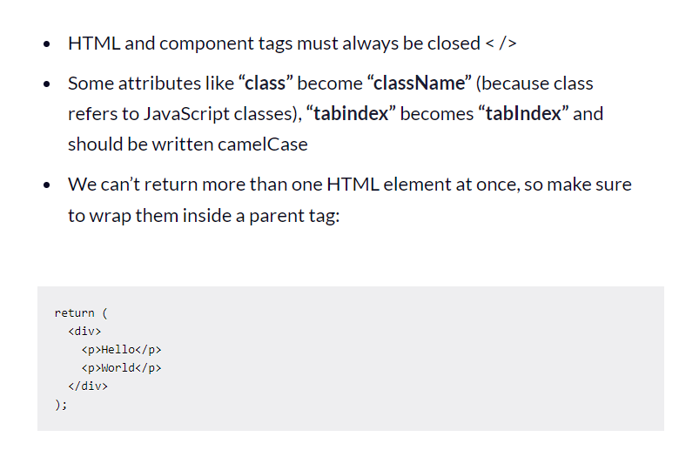

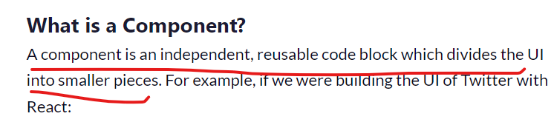

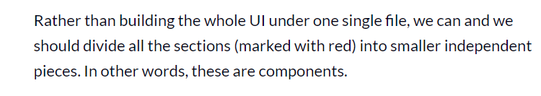

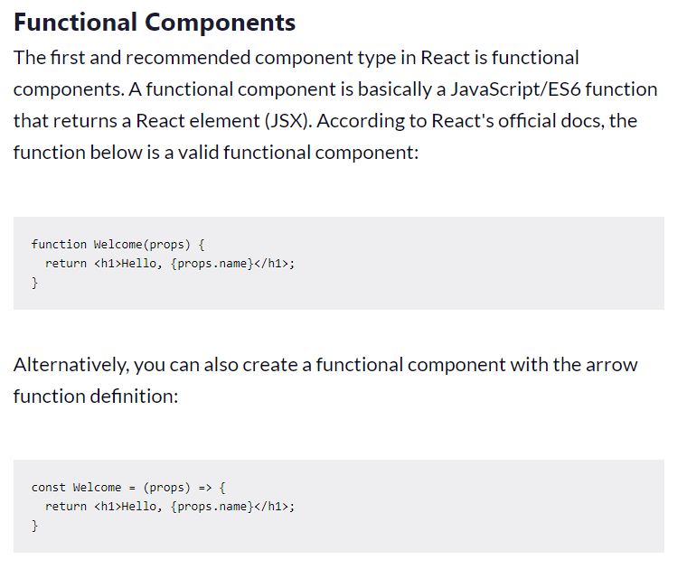

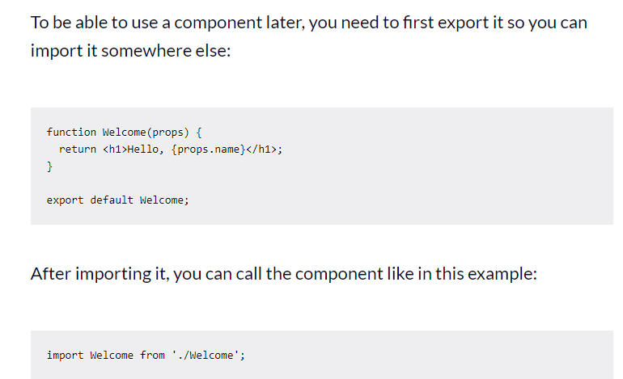

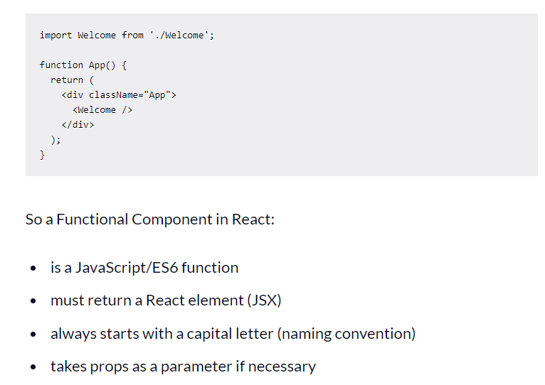

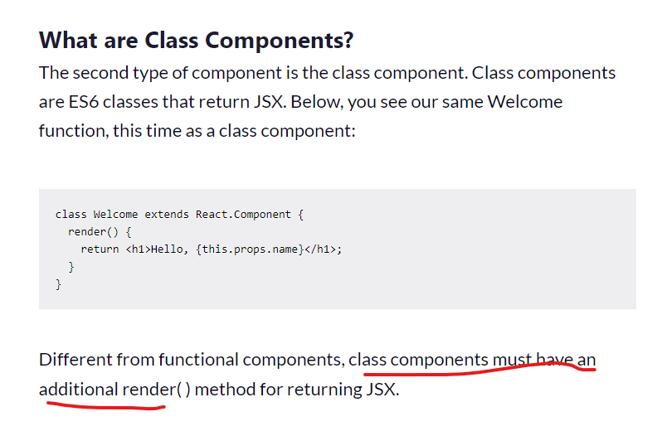

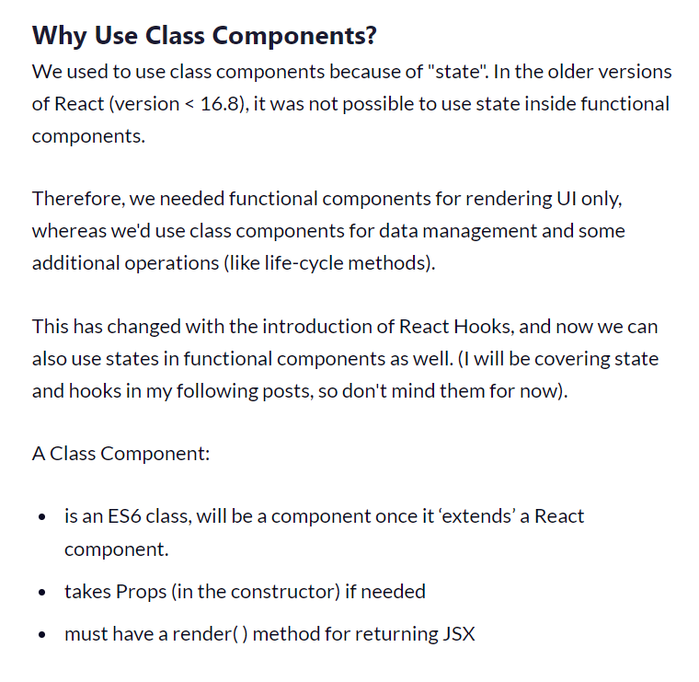

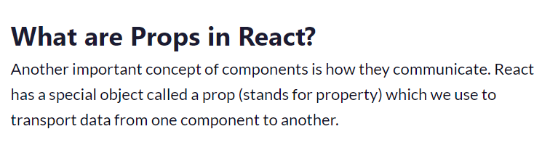

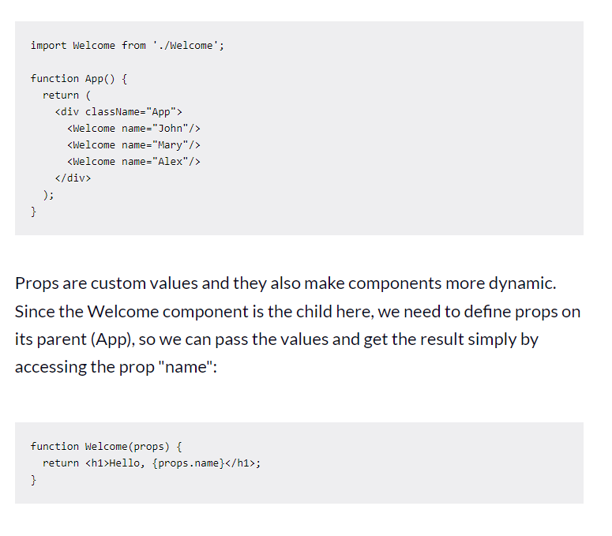

**Functions can take a props argument (an object)**

[**https://reactjs.org/docs/components-and-props.html**](https://reactjs.org/docs/components-and-props.html)

Props are read-only, they are passed down from parent child

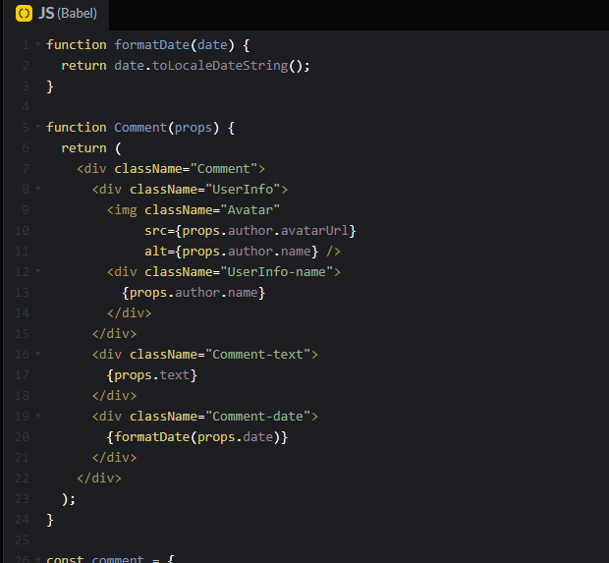  
  
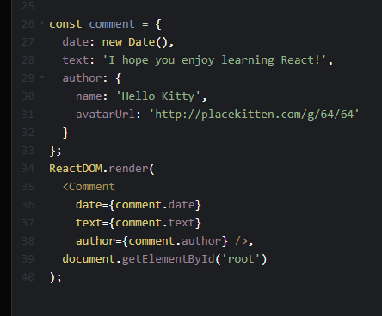

The keyword props does not have to be used, you can pass a single value as child value as shown below

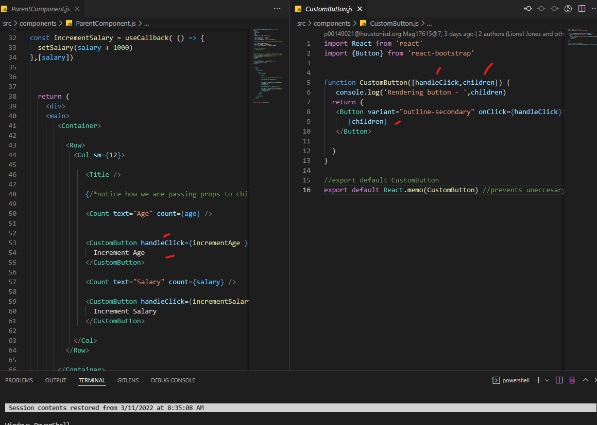

Generally when you use the keyword props (this means a props object that can contain multiple values)

**My Findings on Hooks**

--You use **useState** when you want to use state within your funcional component

const [tblFoodsToBeOmmited, settblFoodsToBeOmmitedData] = useState([])

--you set your state as shown below

async function fetchblFoodsToBeOmmitedData() {

let _FTBOM = [];

var myAPI = new studentInfoApi;

_FTBOM = await myAPI.fetchblFoodsToBeOmmitedData()

//console.log(_FTBOM)

settblFoodsToBeOmmitedData(_FTBOM)

}

--then to use your state variable:

<BootstrapTable data={tblFoodsToBeOmmited} striped hover options={options}

--**useSelector**: Used to tap into your REDUX Store

const counter = useSelector((state) => state.counter);

--**useDispatch** allows you to "dispatch" actions against your REDUX store

const dispatch = useDispatch();

//below is how to use **useCallBack** - keeps a cached copy of a memozized component (export default React.memo(CustomButton))

//and only renders the component that needs to be rendered (not all components ) when a prop or state changes

const incrementAge = useCallback( () => {

setAge(age +1)

},[age])

--this is good for when the DOM changes and you want to perform some other action

**useEffect**(() => {

...... do something else when the DOM changes (like componentDid or DidNot Mount

});

**Working with Parent Child and Props with functional components**

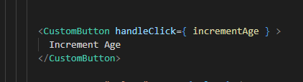

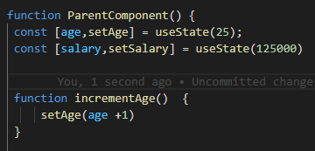

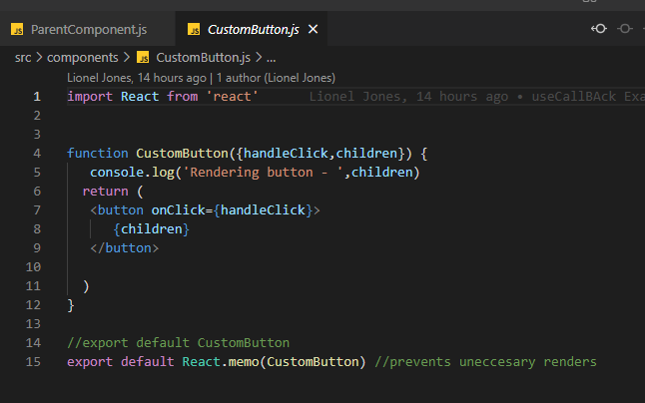

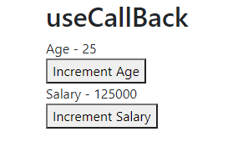

**------------------------------------------------------------------------------------------------------------------------------------------**

**Topic: GitHub**

**GIT**

**Project Locations on GIT**

git clone <https://github.com/lionel5116/SBHISDCustomDevAppsWebAPI.git>

git clone <https://github.com/lionel5116/SandBoxReactWithWebPack.git>

**PUSHING CODE**

git init

**git remote add origin** [**https://github.com/lionel5116/SBHISDCustomDevAppsWebAPI.git**](https://github.com/lionel5116/SBHISDCustomDevAppsWebAPI.git)

git add -A

git add .

git commit -m "Adding PRop example code"

git push origin master

**Tip: PROJECT LOCATIONS**

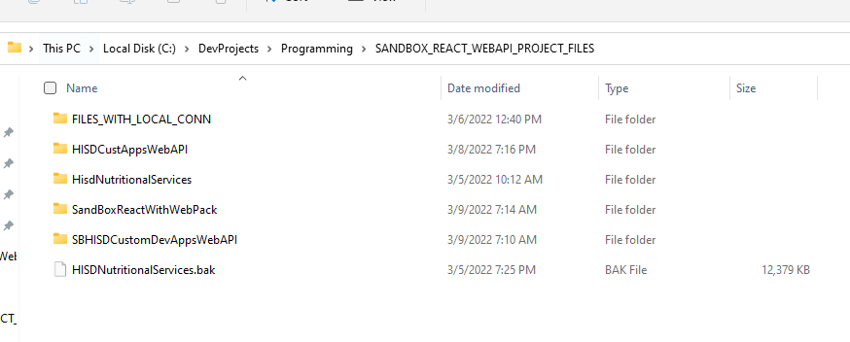

**VIRTUAL DIRECTORY NAME  
HISDCustAppsWebAPI**

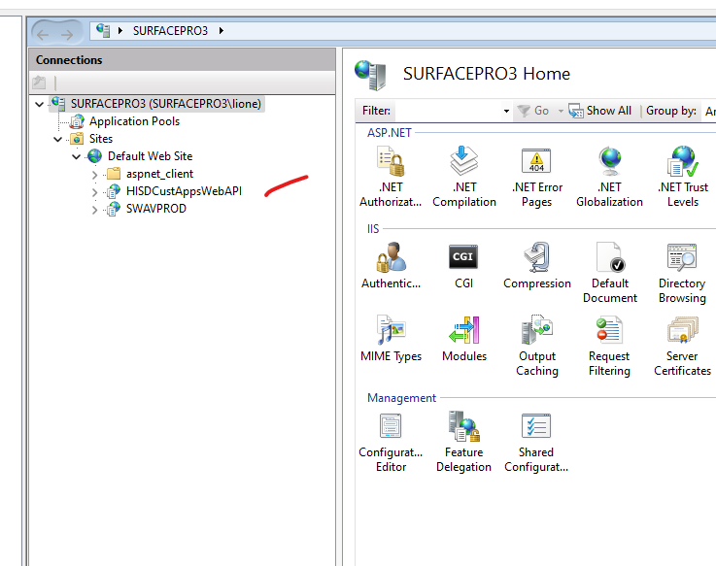

**Topic: REACT HOOKS & REDUX**

**Functional Programming**

https://medium.com/@shaistha24/functional-programming-vs-object-oriented-programming-oop-which-is-better-82172e53a526

From a maintenance, logical and structural standpoint, functional programming excels when there are no histories to deal with. It works particularly well when there are no boundaries required, or those boundaries are already predefined. It thrives in situations where the state is not a factor and there is very little to no involvement with mutable data.

Functional programming provides the advantages like efficiency, lazy evaluation, nested functions, bug-free code, parallel programming. In simple language, functional programming is to write the function having statements to execute a particular task for the application. Each small function does its part and only its part. The function can be easily invoked and reused at any point. It also helps the code to be managed and the same thing or statements does not need to be written again and again. It allows for very modular and clean code that all works together in harmony.

**HOC**

**A HOC is a pure function. That means it has no side effects. It only returns a new component.**

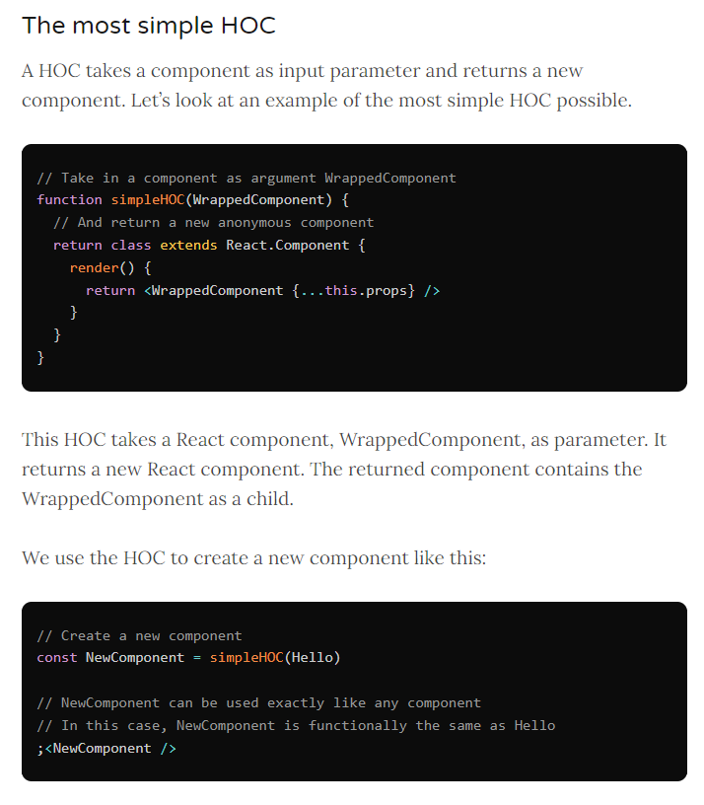

**Below is a good video on how to use react hooks with nodejs API**

<https://www.youtube.com/watch?v=PEGUFi9Sx-U>

**Good Video Series on React**

**React Hooks:**

Allow you to use React features without having to write a class, Ex; State of a component

<https://www.youtube.com/watch?v=cF2lQ_gZeA8&list=PLC3y8-rFHvwgg3vaYJgHGnModB54rxOk3&index=44>  
  
**React Effects**  
Mimics lifecycle hooks for a functional component. i:e componentDidMount, it essentially adds "effects" to a functional component

<https://www.youtube.com/watch?v=BH4xvzHa7H8&list=PLC3y8-rFHvwgg3vaYJgHGnModB54rxOk3&index=52>

**Great Article on React Hooks with REDUX**

<https://thoughtbot.com/blog/using-redux-with-react-hooks>  
**How to use Redux with Hooks**

React Redux now includes its own useSelector and useDispatch Hooks that can be used instead of **connect**.

**useSelector** is analogous to connect’s **mapStateToProps**. You pass it a function that takes the Redux store state and returns the pieces of state you’re interested in.

**useDispatch** replaces connect’s **mapDispatchToProps** but is lighter weight. All it does is return your store’s dispatch method so you can manually dispatch actions. I like this change, as binding action creators can be a little confusing to newcomers to React Redux.

Alright, so now let’s convert a React component that formerly used connect into one that uses Hooks.

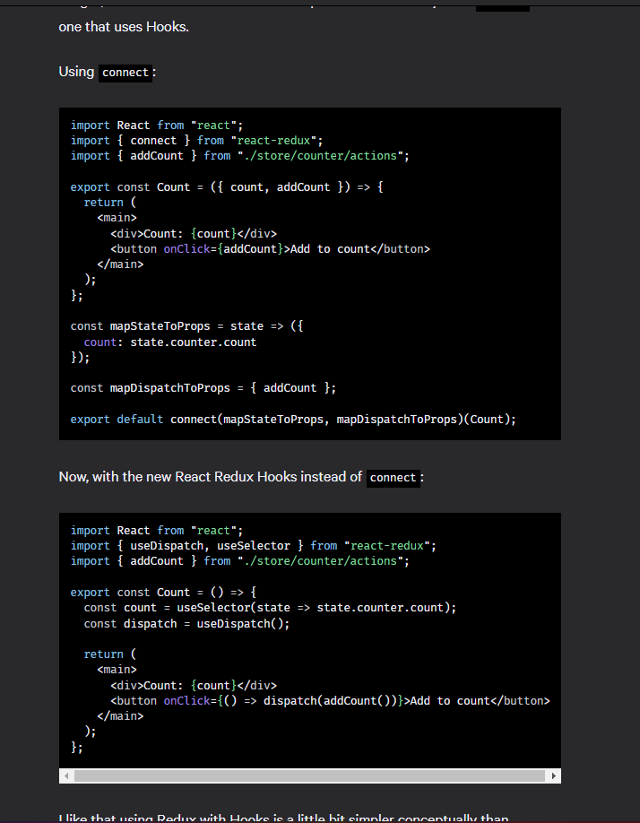

**Here a working example – This is in the sandbox project**

<https://www.freecodecamp.org/news/learn-redux-by-making-a-counter-application/>

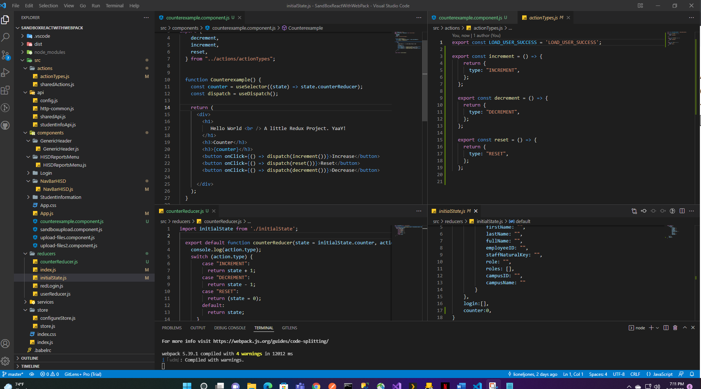  
  
**And it works:**

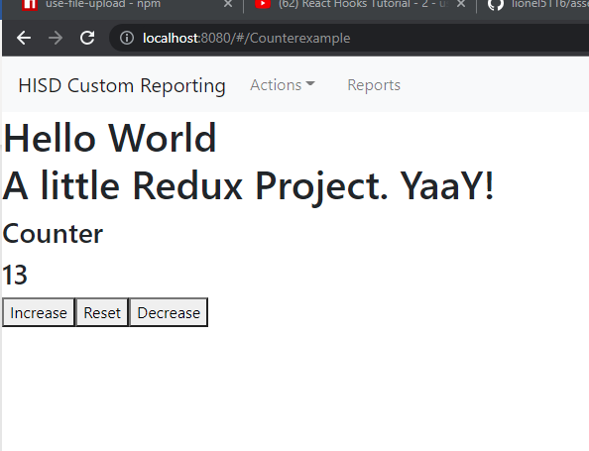

**­­A recap of REDUX  
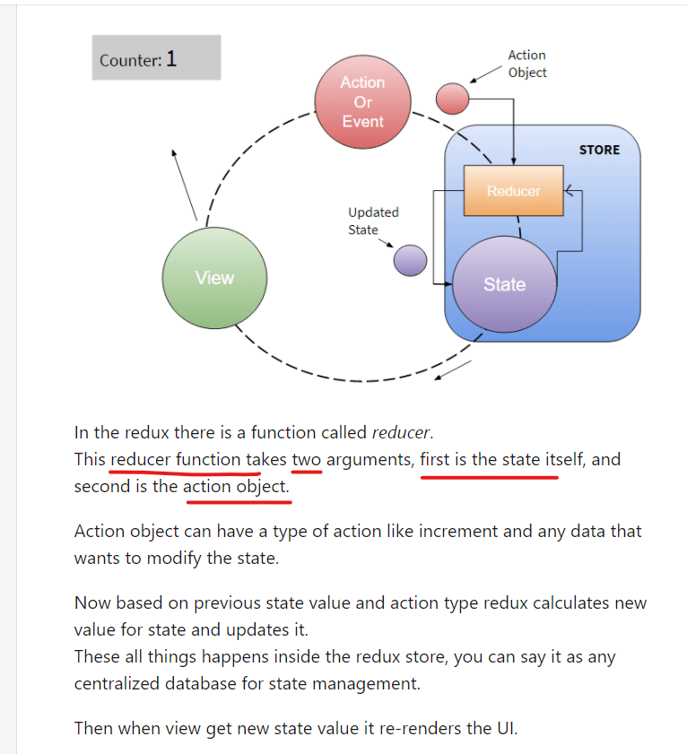  
Actions:  
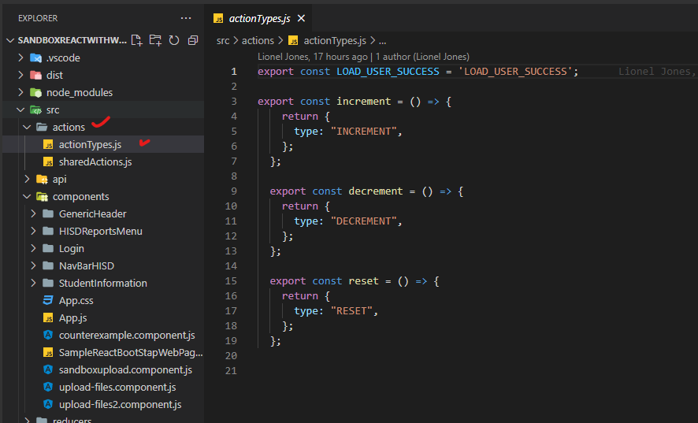  
  
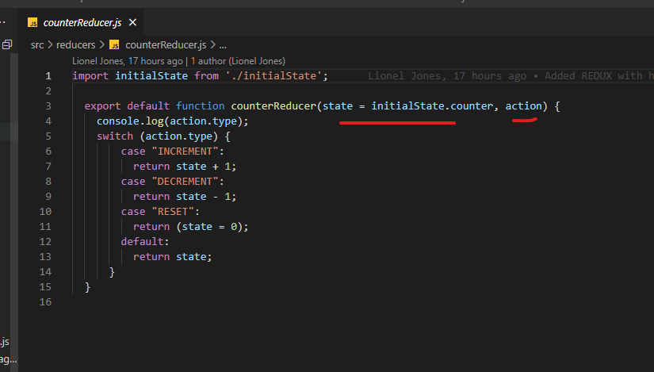**

**Definition of a pure function**

A function application has no side effects (no mutation of local static variables,

non-local variables, mutable reference arguments or input/output streams).

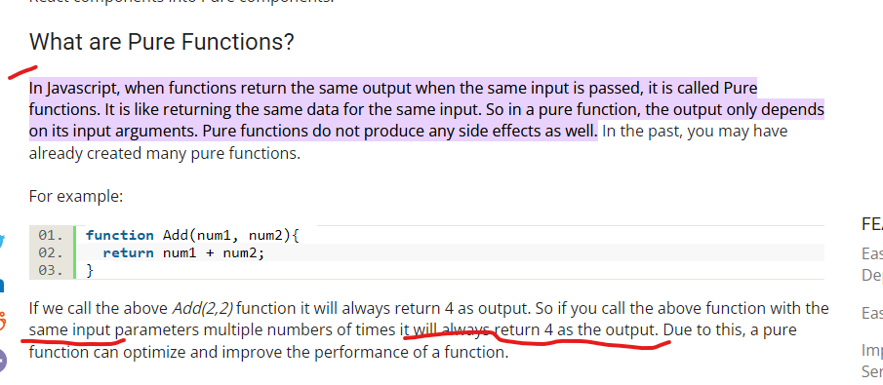

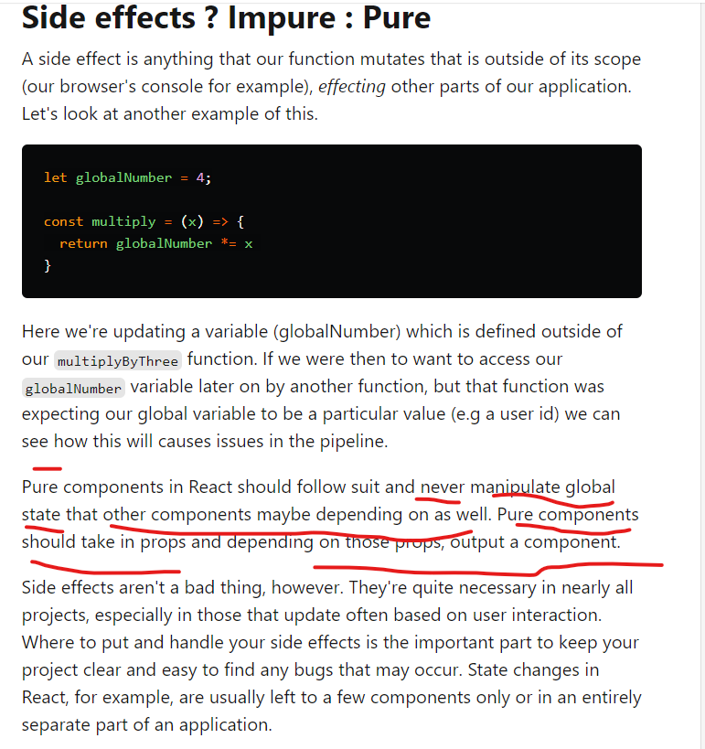

**Use Effect**[**https://reactjs.org/docs/hooks-effect.html**](https://reactjs.org/docs/hooks-effect.html)Since we are using pure functions, (that don’t allow for side effects), the only way to add side effects is to use .. well (useEffect)

**Understanding Side Effects**

React is centered around functional programming. A side effect is any execution that affects something

outside the scope of the function being executed. It is not a React specific term,

it’s a general concept about the behavior of a function. For example, if a function modifies a

global variable, then that function is introducing a side effect —

the global variable doesn’t belong to the scope of the current function.

Data fetching, setting up a subscription, and manually changing the DOM in React components are all

examples of side effects. Whether or not you’re used to calling these operations “side effects”

(or just “effects”), you’ve likely performed them in your components before.  
  
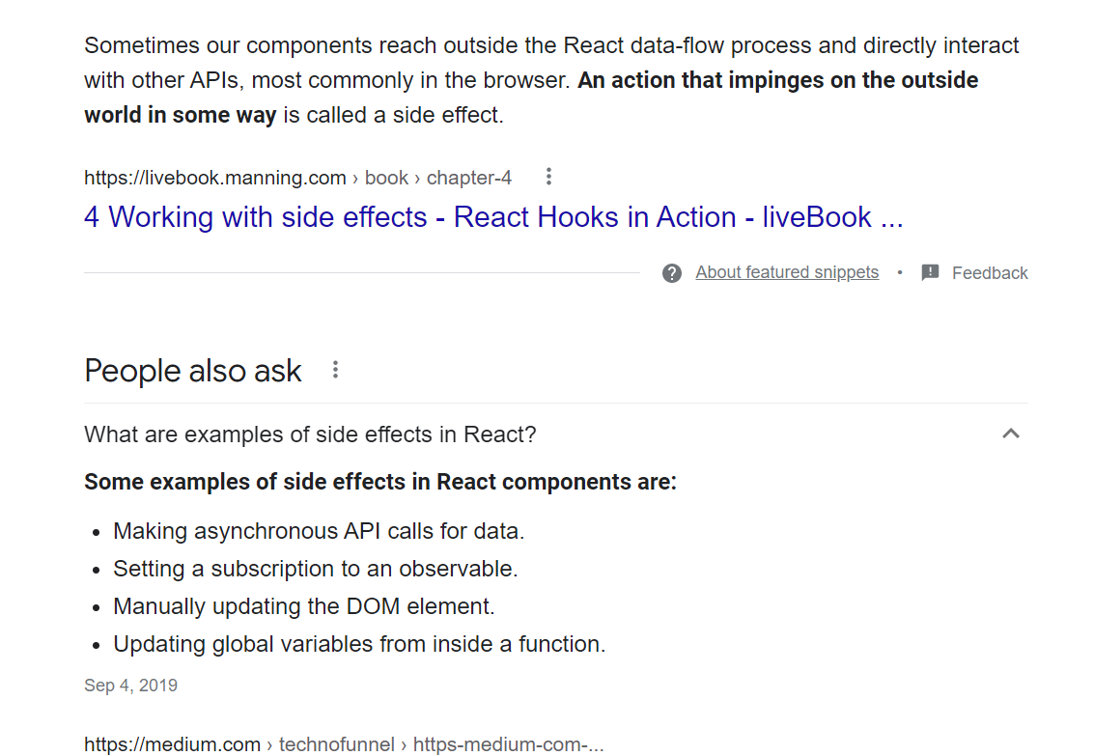

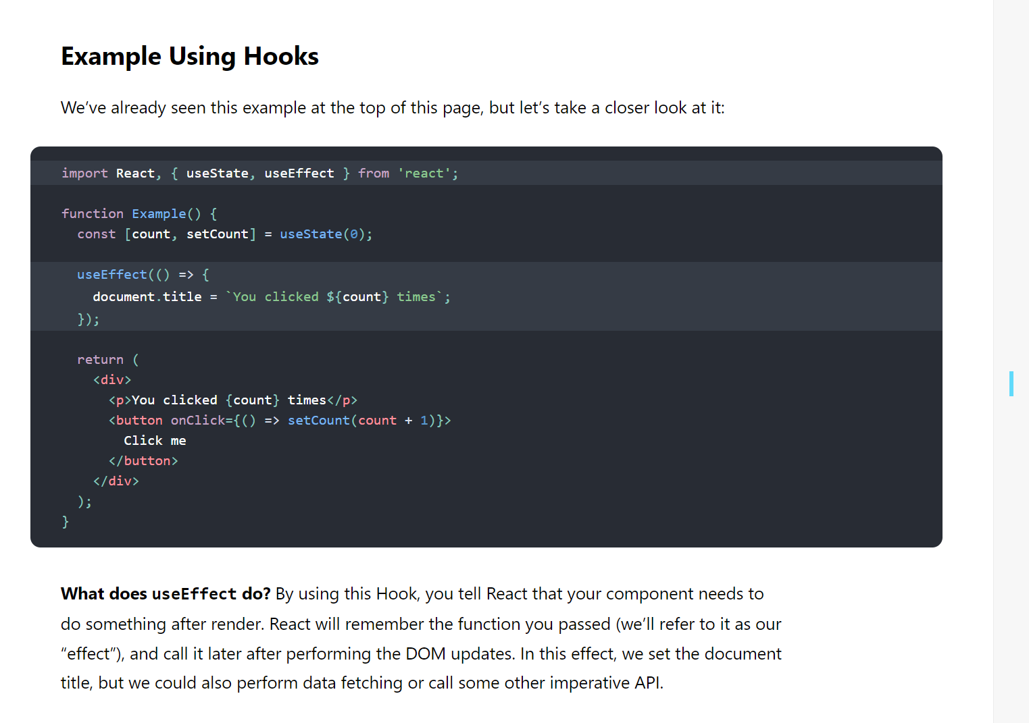

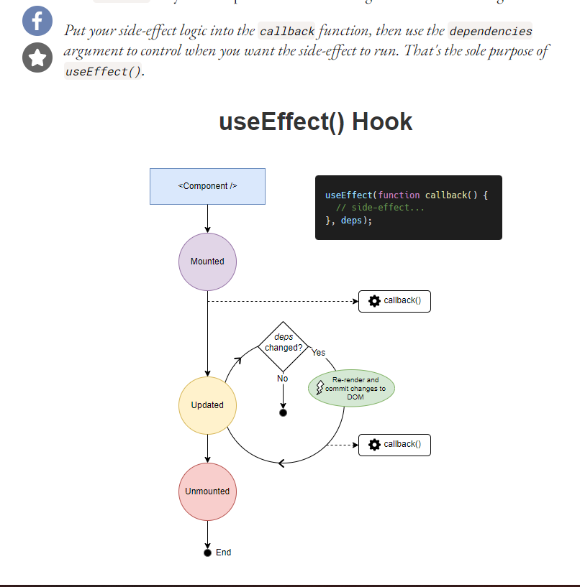

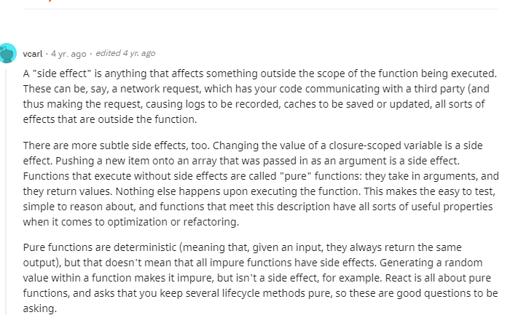

**To keep useEffect from an infinite loop, use and empty array as the dependent argument as explained below**

**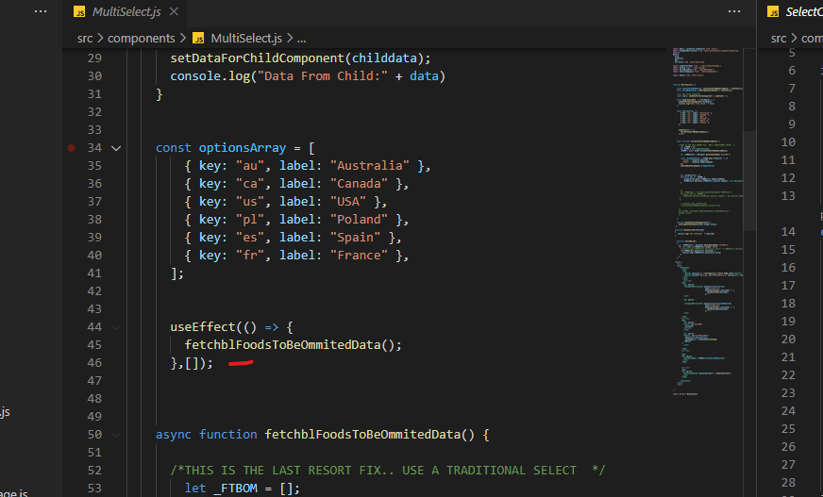  
When I did not include the empty array in the useEfffect, it ran over 1,000 times**

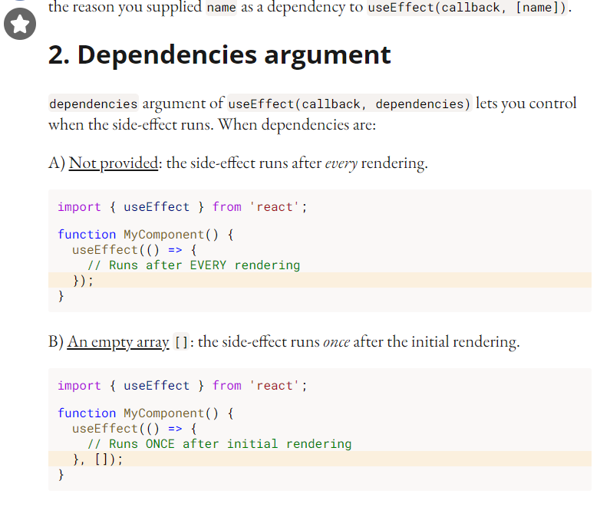

**MORE REDUX HERE**

<https://reactjs.org/docs/hooks-state.html>  
What is a hook in functional programming  
A Hook is a special function that lets you “hook into” React features  
**When would I use a Hook?**

If you write a function component and realize you need to add some state to it,

previously you had to convert it to a class. Now you can use a Hook inside the existing function component  
  
**Example:**

const [count, setCount] = useState(0);

What do we pass to useState as an argument? The only argument to the useState() Hook is the initial state.

Above we pass in 0 as the initial value

What does useState return?

It returns a pair of values: the current state and a **function** that updates it.

This is why we write const [count, **setCount**] = useState()

This is similar to this.state.count and this.**setState** in a class

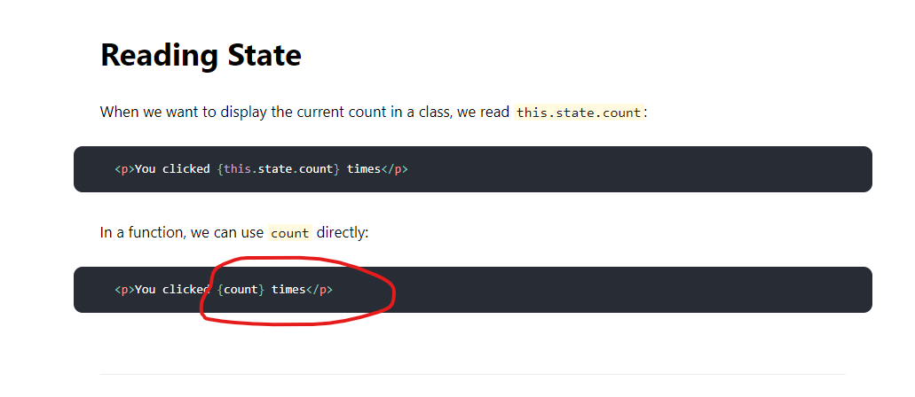

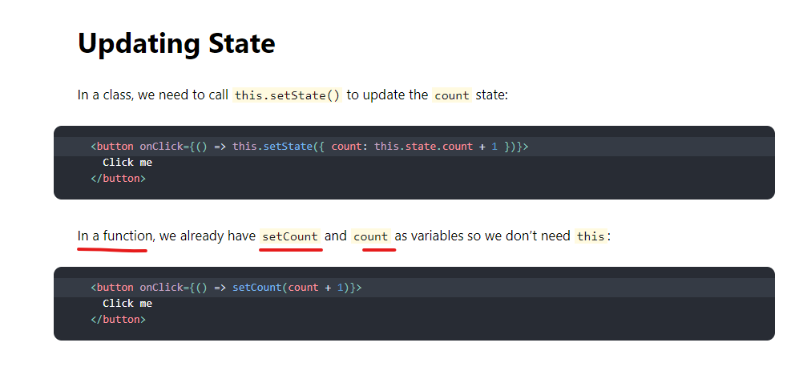

Real world example I used in my file upload component example:  
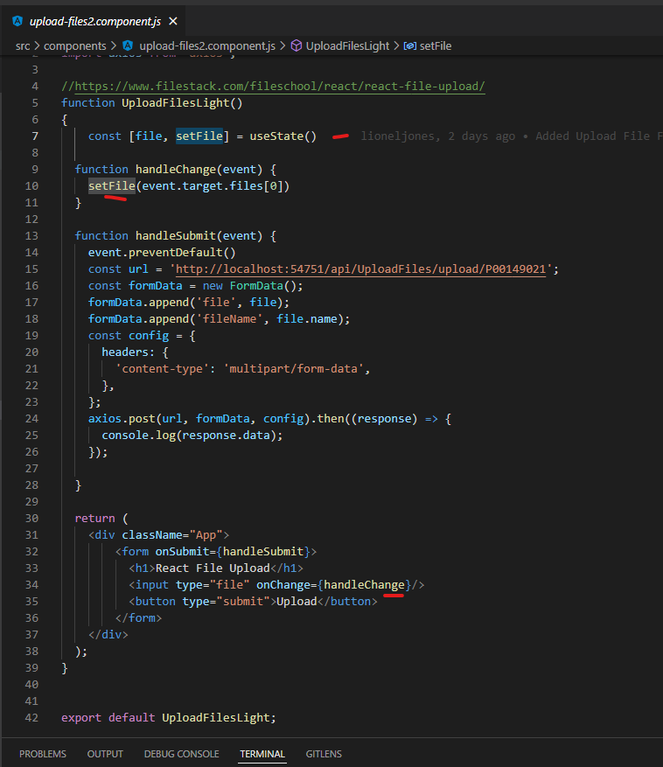

**Topic: REACT PAGE LAYOUT**

For Components used by bootstrap react

<https://react-bootstrap.github.io/components/alerts/>

**React Bootstrap5 Sample Page Demo**

<https://www.youtube.com/watch?v=l2131Rok8XU>  
We implemented a react bootstrap web page  
**NOTE**: WE ALSO DID LIVE MARKUP CODING, WE STARTED THE WEBSITE AND CODED AND SAVED THE FILE WHILE IT DID LIVE RELOADING!!!  
Docs:  
<https://react-bootstrap.github.io/getting-started/introduction>  
Page: “SampleReactBootStrapWebPage.js”  
Key Notes on the Page  
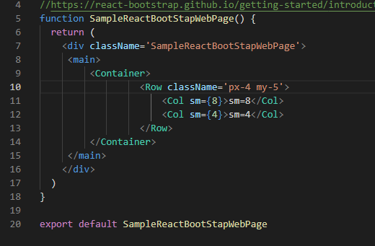  
  
The **’px-4 my-5’** is padding an margins in bootstrap react  
  
**Responsive Grids:**  
<https://react-bootstrap.netlify.app/layout/grid/#grid-system>  
  
**Images**  
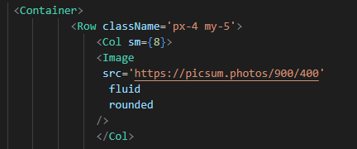 **ClassName Keyword**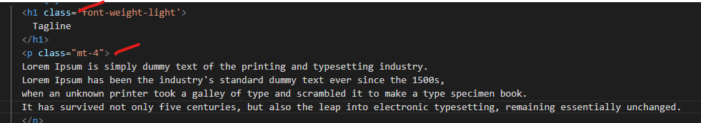

**Notice how when you using regular markup (not components):**class (for regular elements)  
className (for components)  
  
https://react-bootstrap.github.io/components/cards/  
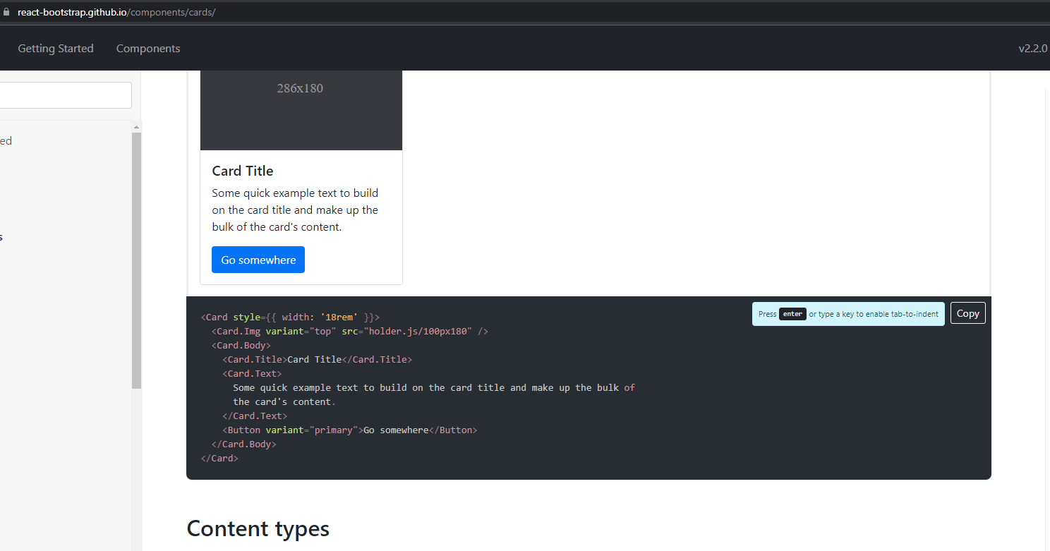  
He also just copied and pasted the sample card code from the website (sweet), just like regular bootrap example coding  
  
After coding:

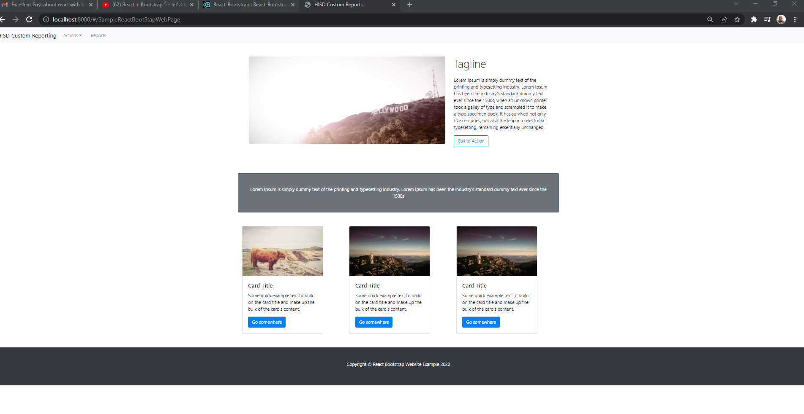  
SWEET!!!!!  
He also has some information on free web page hosting of your react application, kinda like Heroku  
<https://www.youtube.com/watch?v=VLGLlIhn3Ng>  
  
For spacing in bootstrap react

https://getbootstrap.com/docs/5.1/utilities/spacing/  
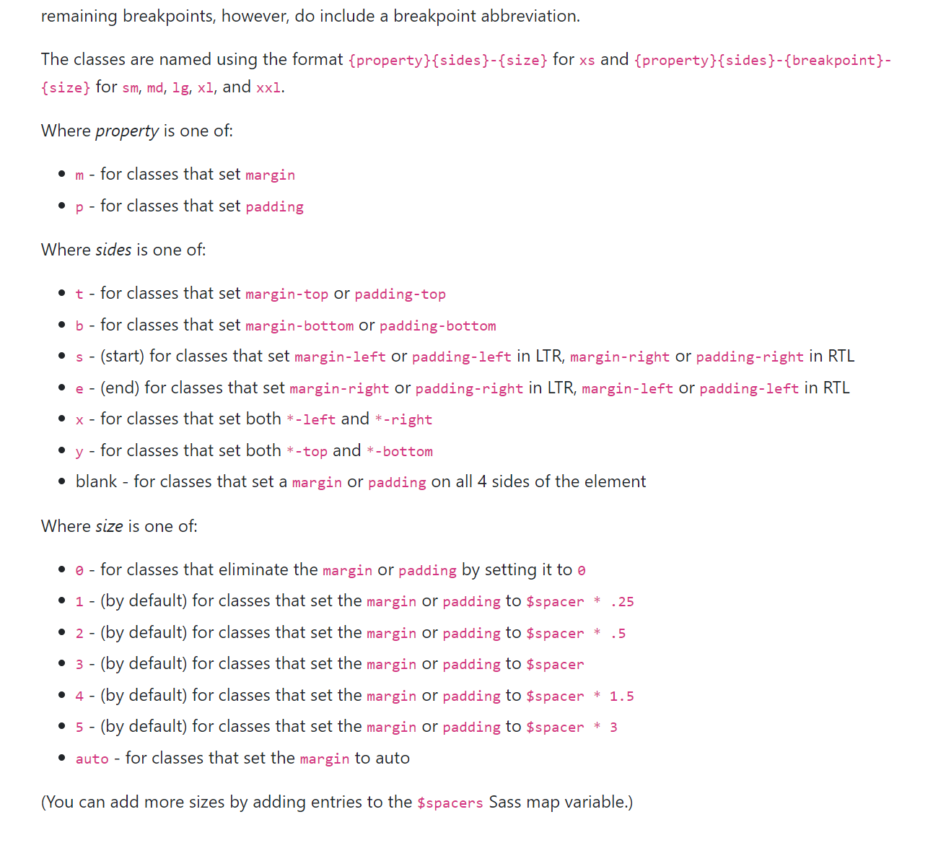  
**You first specify what spacing you want either:**  
m (margin)  
p( padding)  
Then you specify the sides  
t (top  
b(bottom)  
…..  
Then a # between 0 and 5 (also auto) (You cannot specify any other numbers)

So for this example below, he used “mt-4” (margin-top) with a 4 spacer (* 1.5)

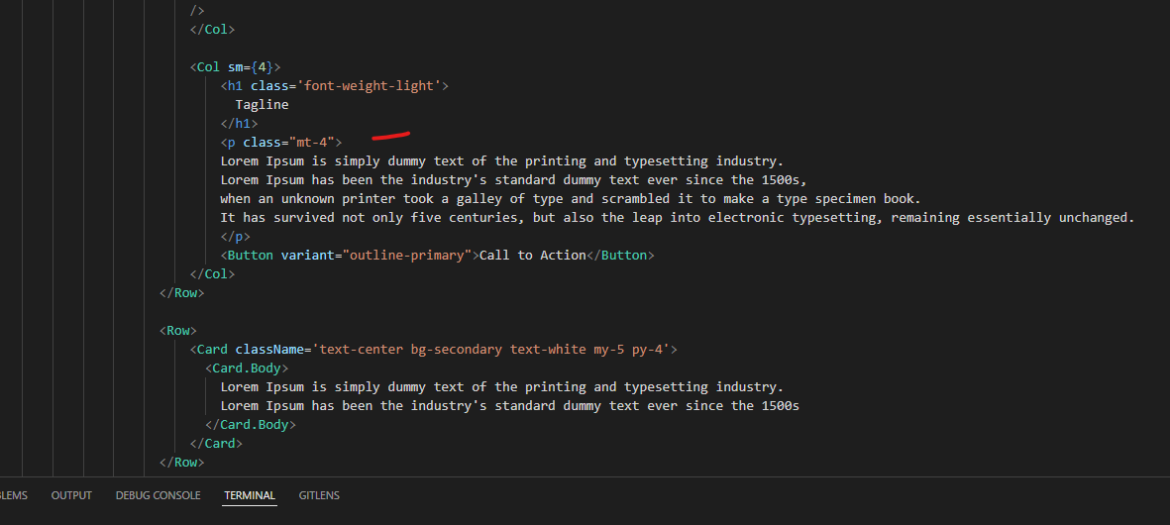

And for Text  
https://getbootstrap.com/docs/5.1/utilities/text/  
Its in the docs

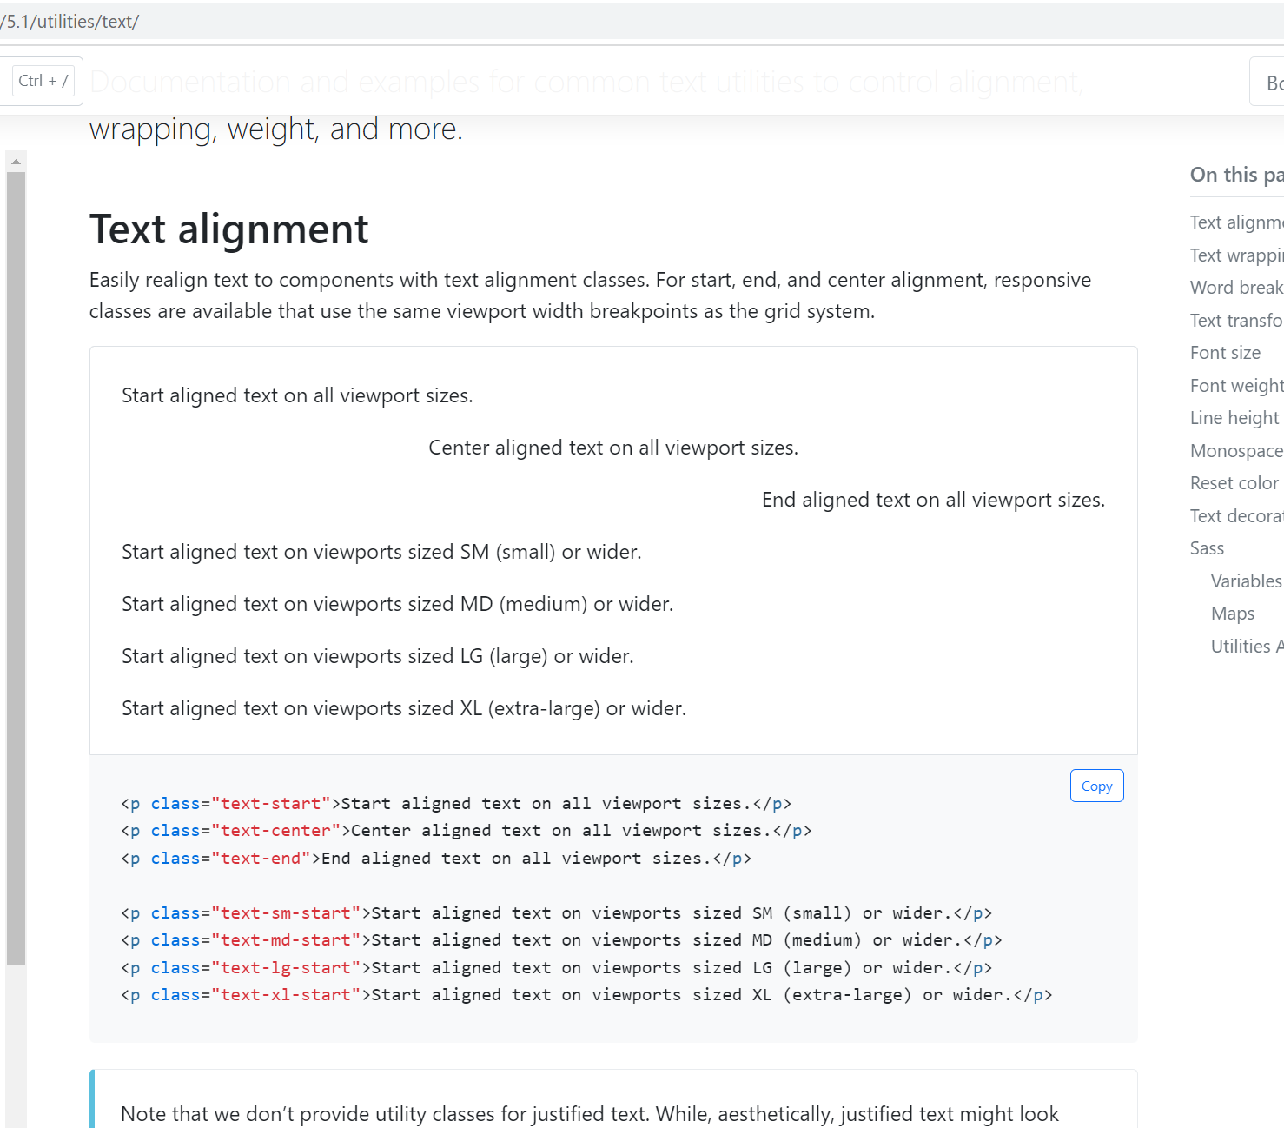  
  
For example:

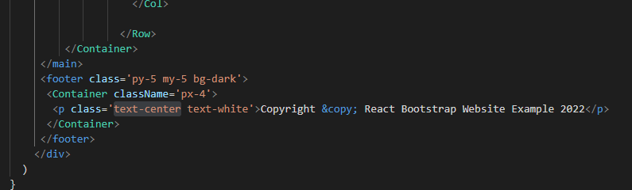

**Adding a Custom Style css attribute**

If you want to add your own custom style for a component, you have to use in the format below:  
{ { <style: ‘ ‘}}  
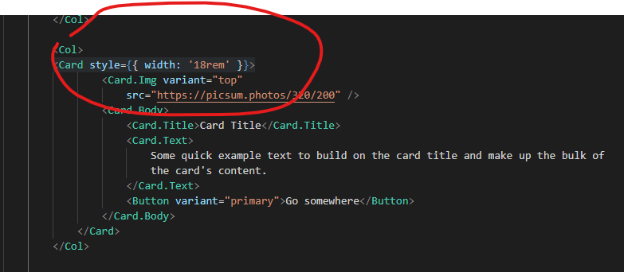

**Topic: DEPLOYMEMT**

**Testing the App out at HISD**  
Nutritional Services  
Server - SQLINT01  
NutritionalServices  
User Name : u_NutSvs  
Password: 8~QXCob/Zp  
  
Building the project  
**run npm build**

Changed the web.config file’s connection string out in the WEBAPI Project  
Published the files out the Dev Server  
  
On the Server  
WAPPDEVWEB01  
  
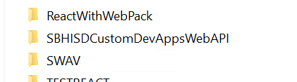  
  
Named the Virtual Directory  
SBHISDCustomDevAppsWebAPI  
  
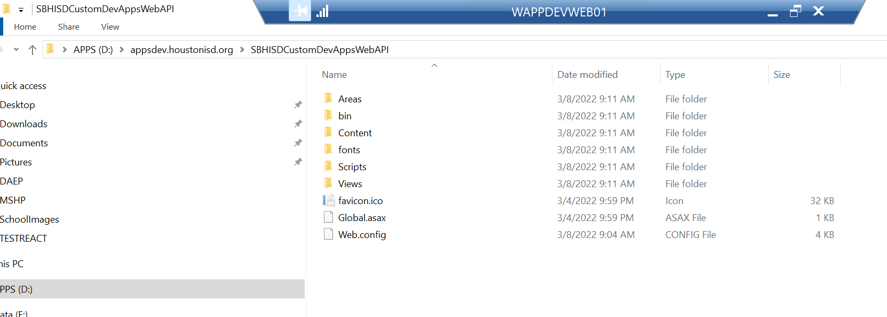  
  
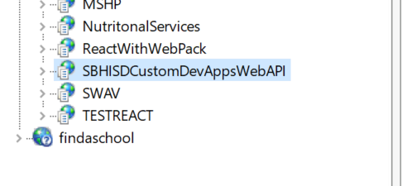  
  
<http://appsdev.houstonisd.org/SBHISDCustomDevAppsWebAPI>

**The Final URLS:**  
<http://appsdev.houstonisd.org/SBHISDCustomDevAppsWebAPI>  
<http://appsdev.houstonisd.org/SandBoxReactWithWebPack>

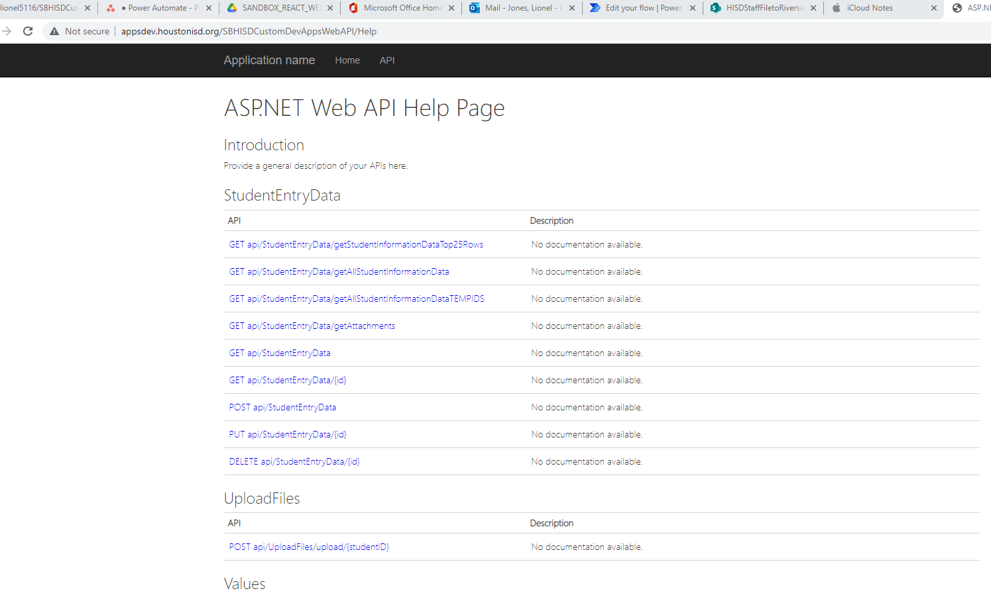  
  
Now for installing the React App  
I changed the config.js file:  
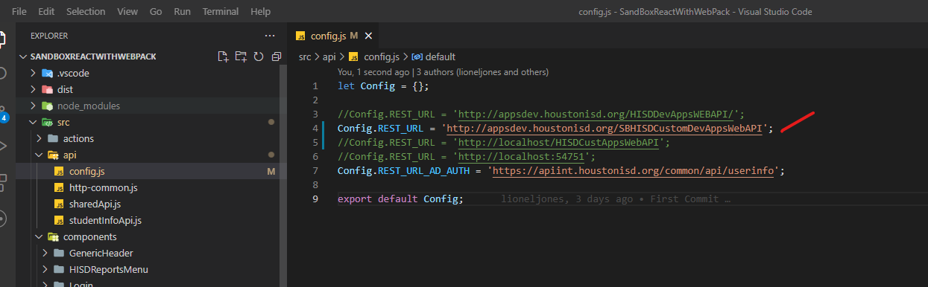  
  
Did a test to see if the files would upload from my local build  
  
Looked at SQL  
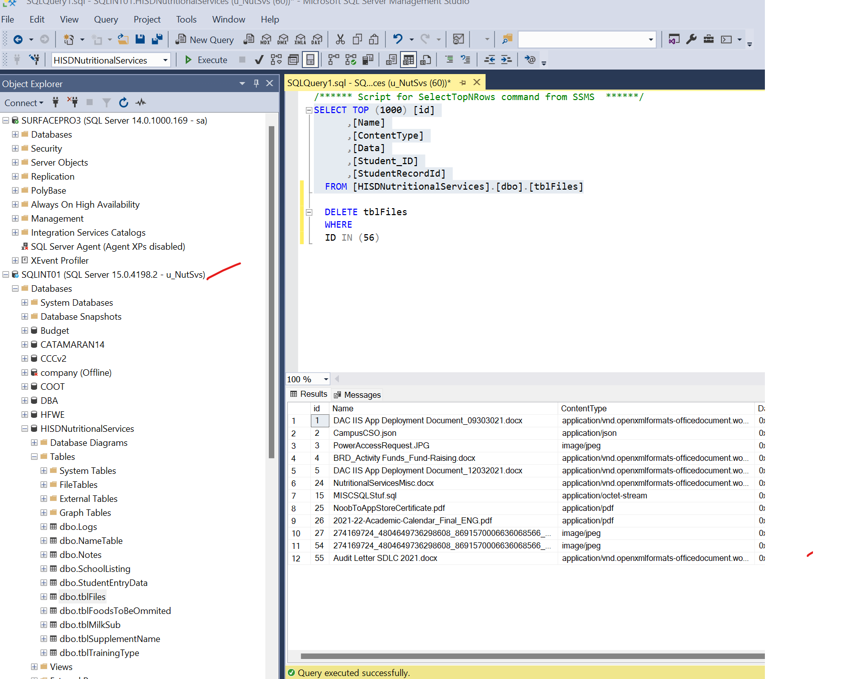  
  
Ran the page  
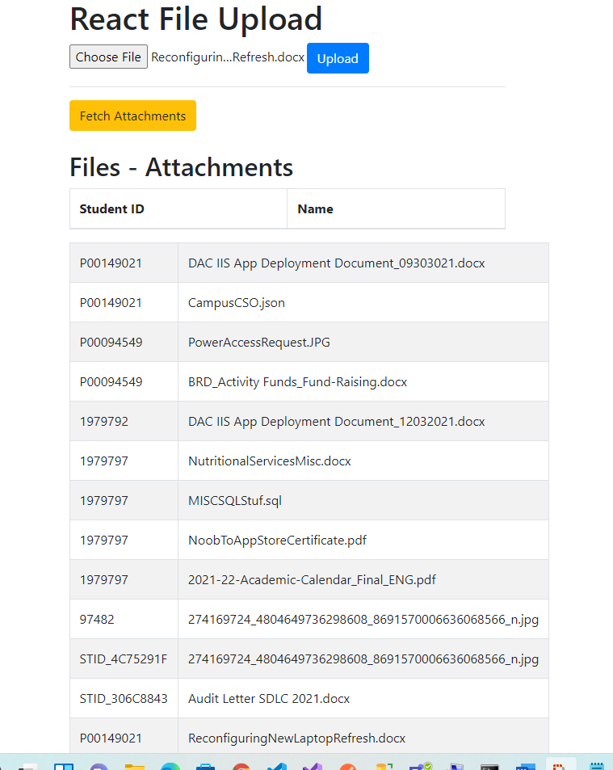  
  
And it works

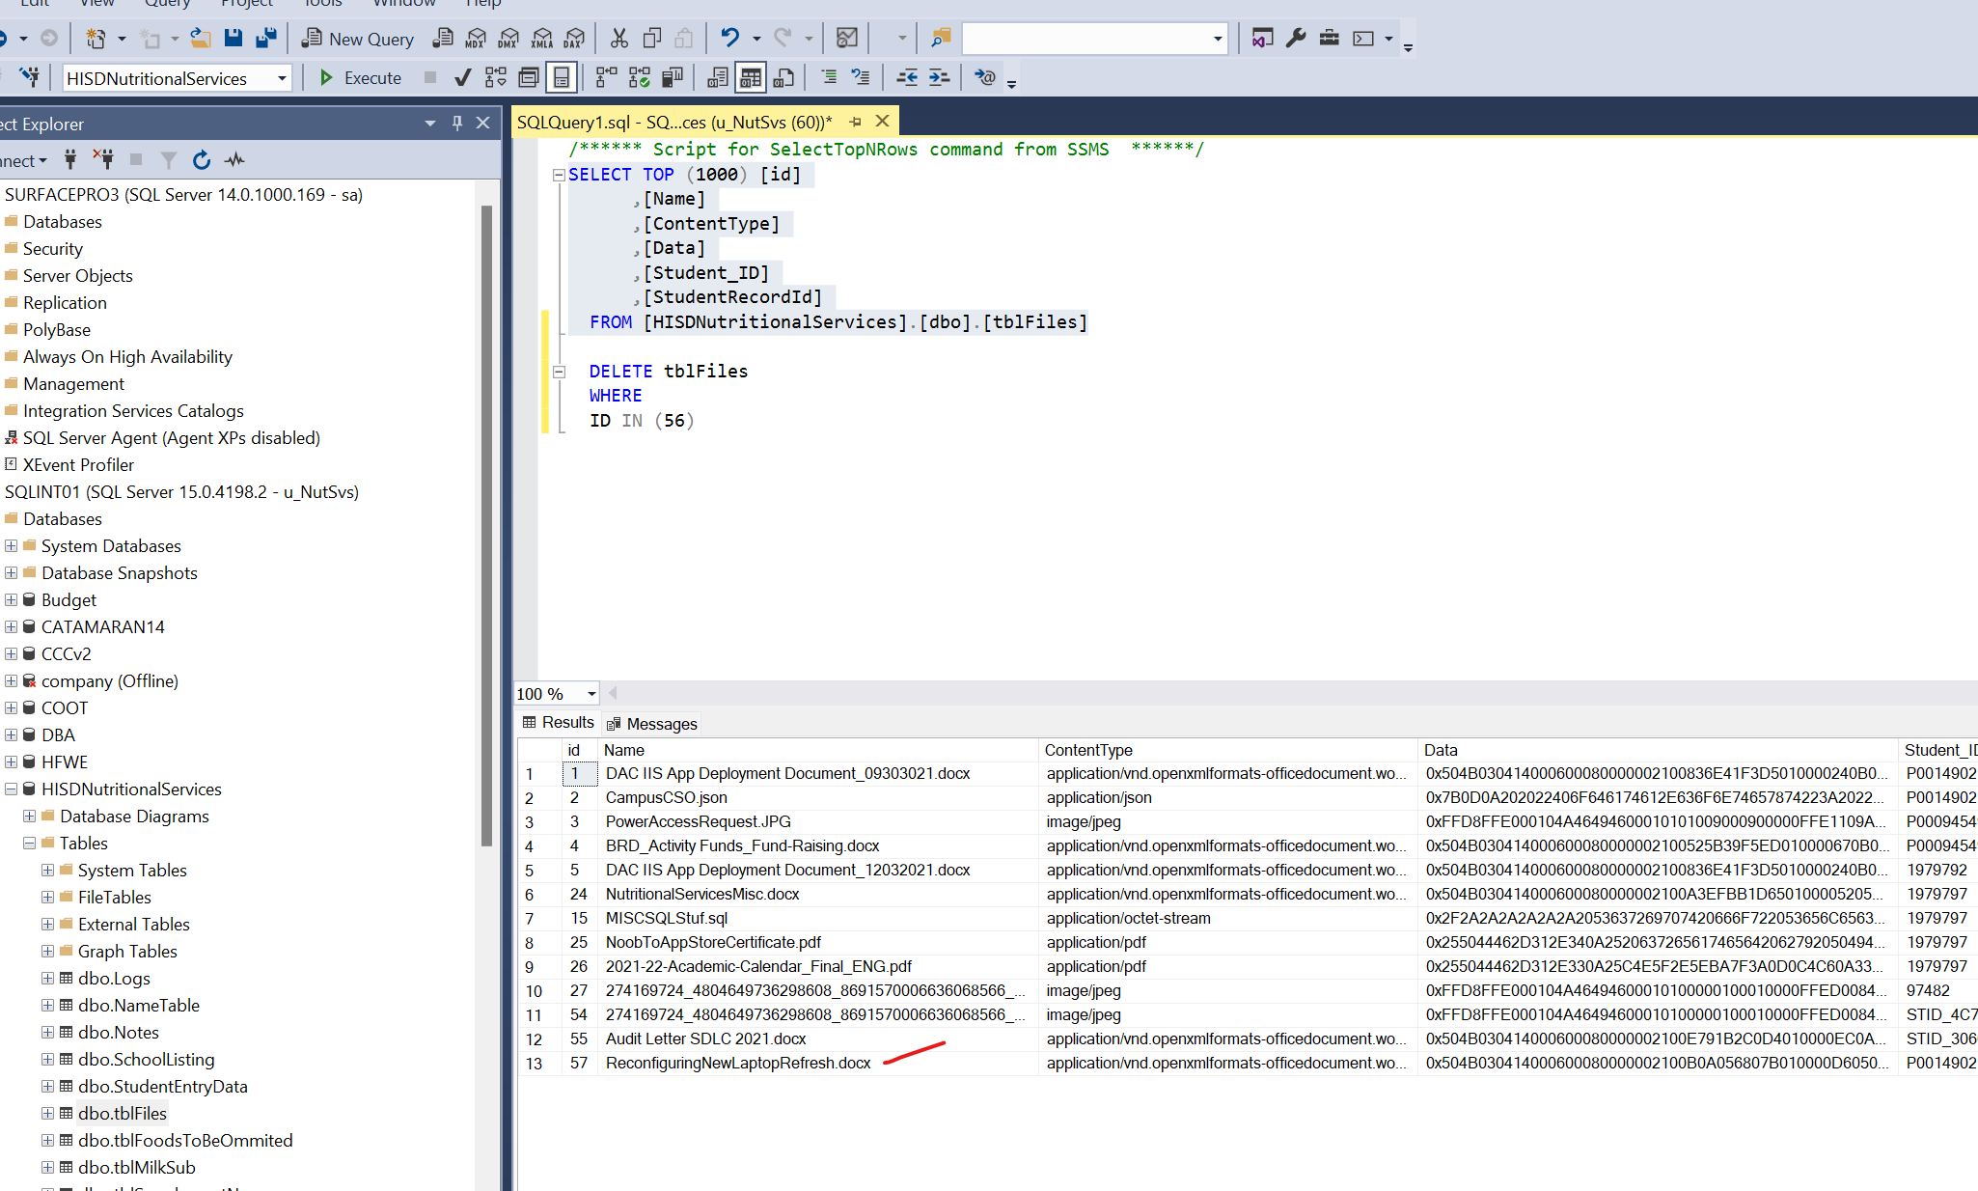

Now I am going to do a build and deploy:  
npm run build  
  
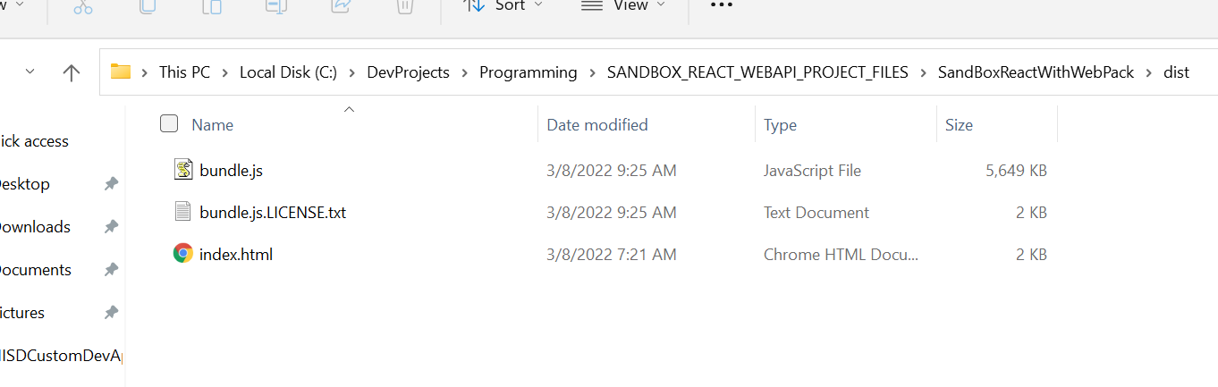  
  
  
I named web application the same as the project on the dev server  
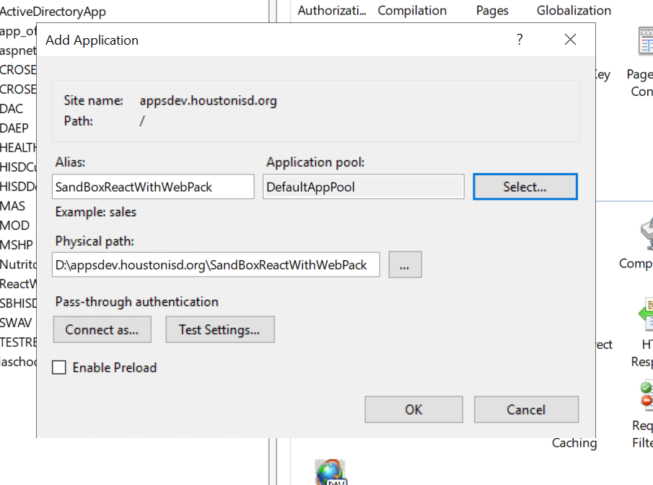

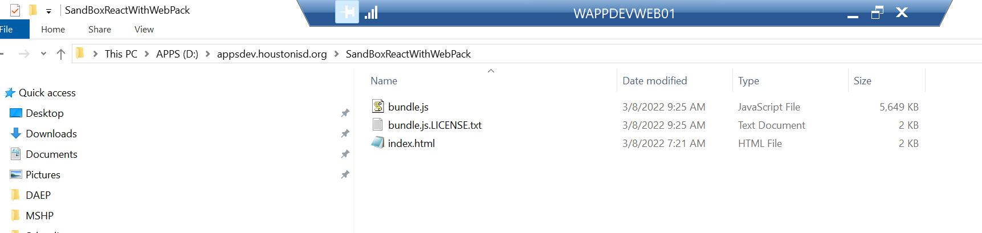  
  
The URL

<http://appsdev.houstonisd.org/SandBoxReactWithWebPack>  
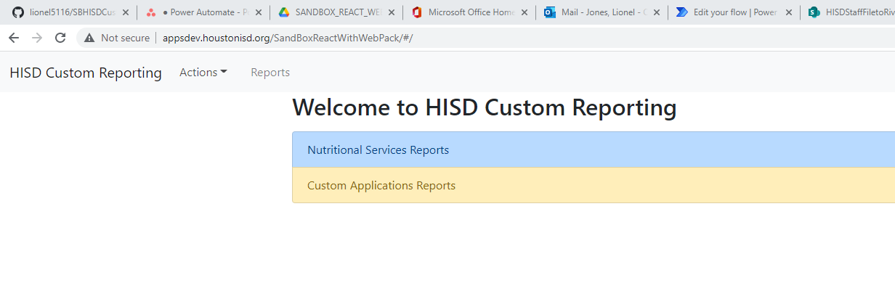  
  
Starting the test:

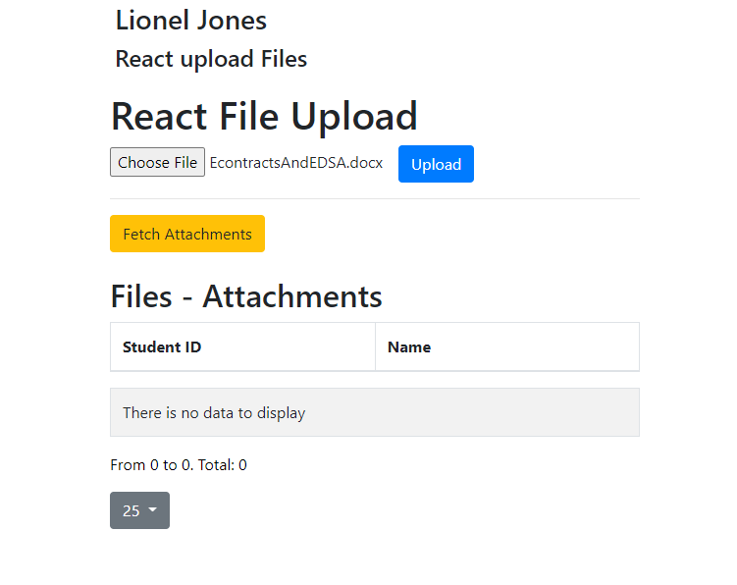  
And it works:

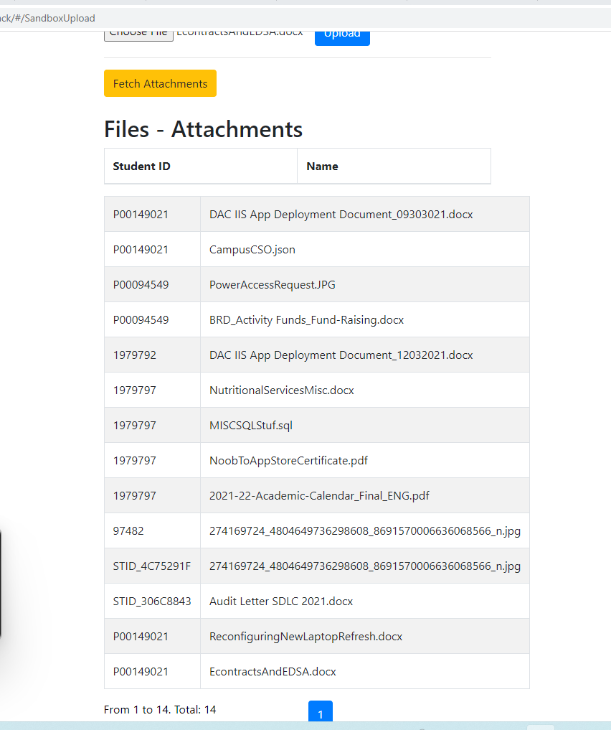  
  
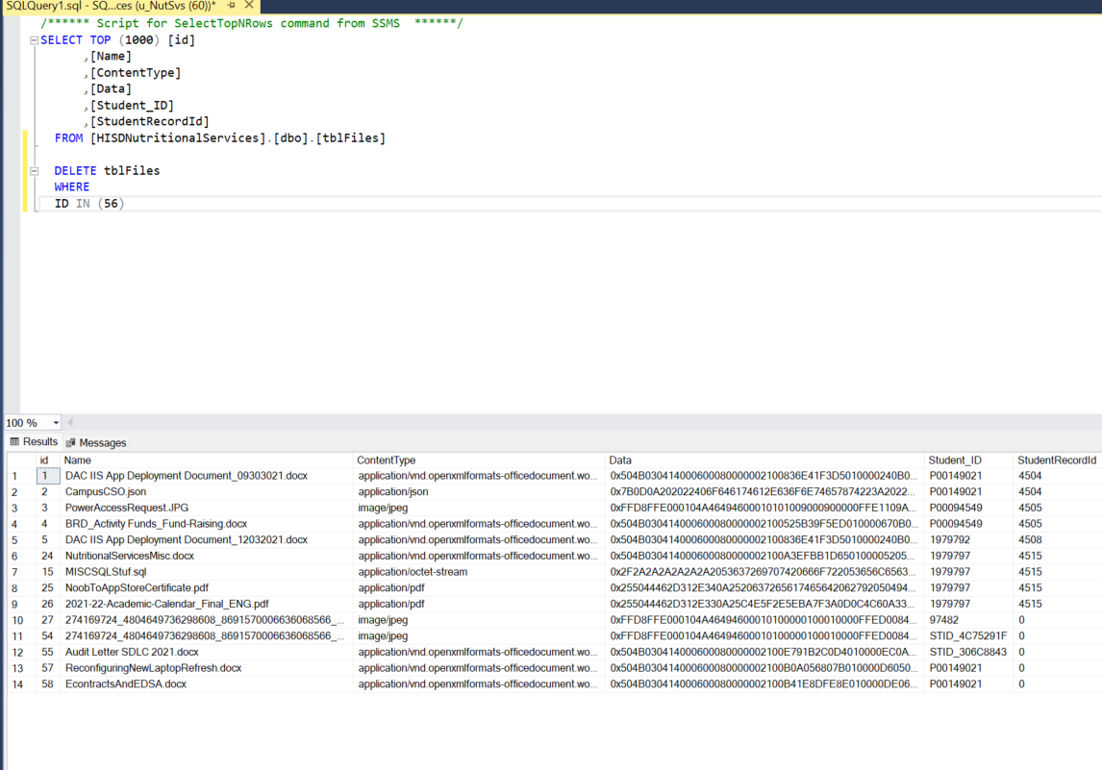

**Topic(s): HELPER – TROUBLESHOOTING TOPICS**

**How to kill server when seeing “EADDRINUSE: address already in use”**

<https://levelup.gitconnected.com/how-to-kill-server-when-seeing-eaddrinuse-address-already-in-use-16c4c4d7fe5d>

C:\Users\admin>netstat -ano|findstr "PID :3000"

Proto Local Address Foreign Address State PID

TCP 0.0.0.0:3000 0.0.0.0:0 LISTENING 18264

To kill this process (the /f is force):

taskkill /pid 18264 /f

**Issue running npm install and running your project**

For HISD  
**First check your node version**  
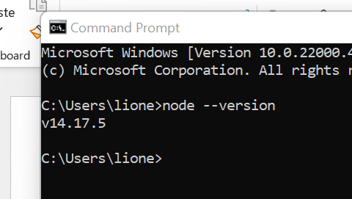

If you are having an issue getting the node_modules to install running   
npm install  
Delete the **node_modu**les directory  
Make sure you don’t have any files open or in use in your project  
Open a command prompt as “Administrator”  
run  
npm install  
If no errors, run  
npm run start:dev  
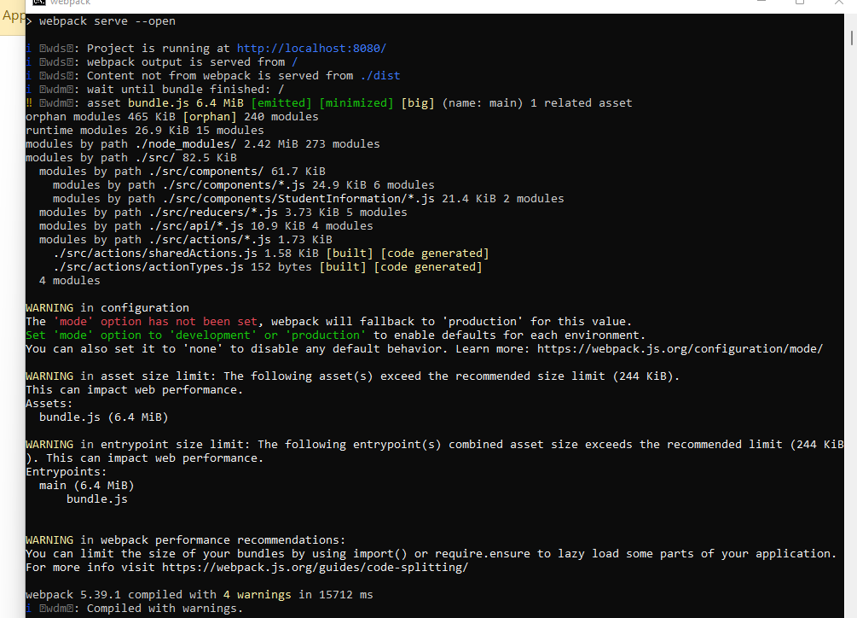

**Handling React Errors with the DOM -Rendering  
When you see something like this:**

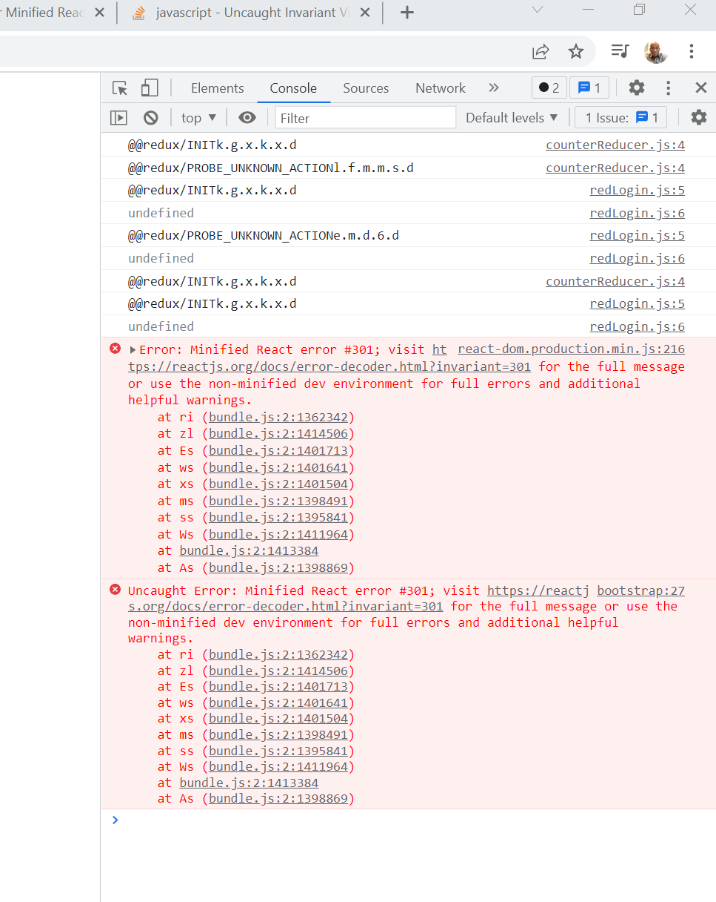

You can click on the link to see the true error:

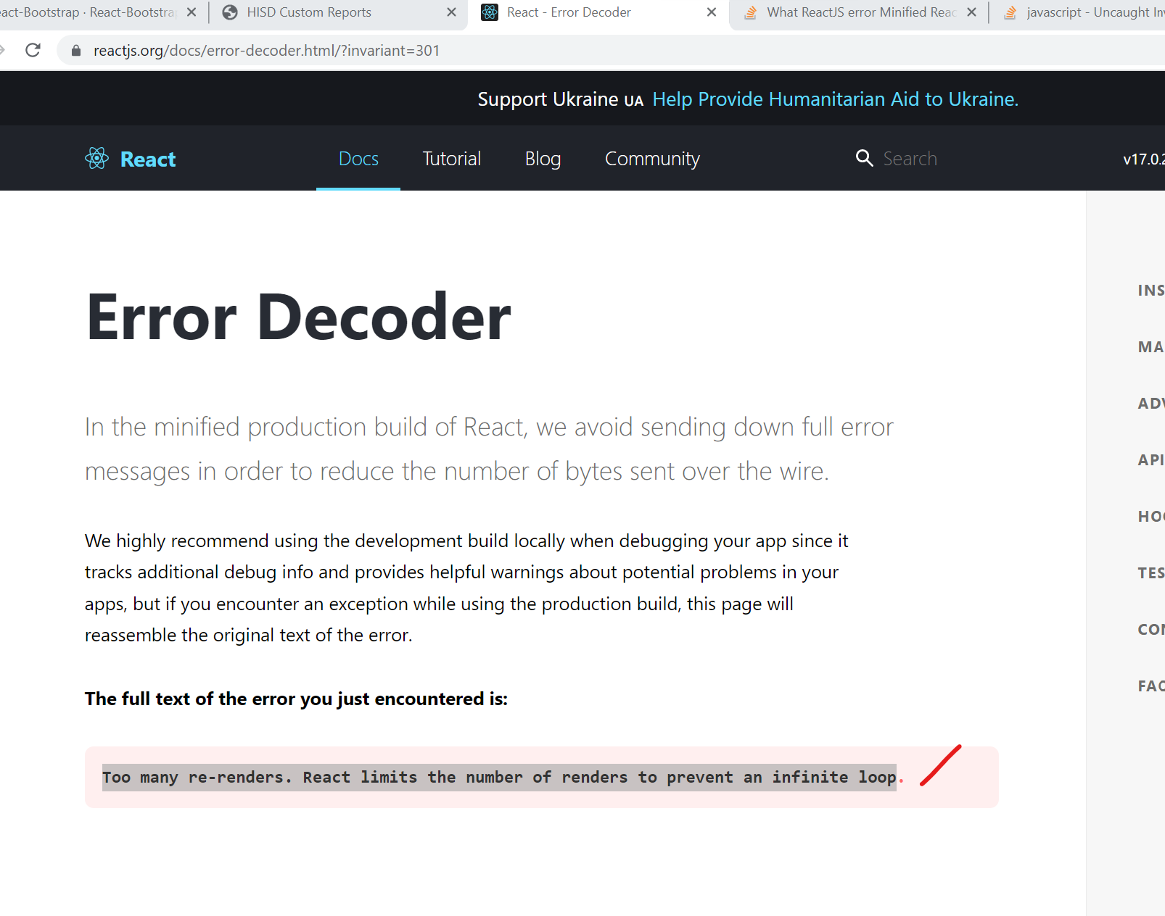  
  
In this case it was the way that I had one of my functions coded inside of one of my components

This was the fix

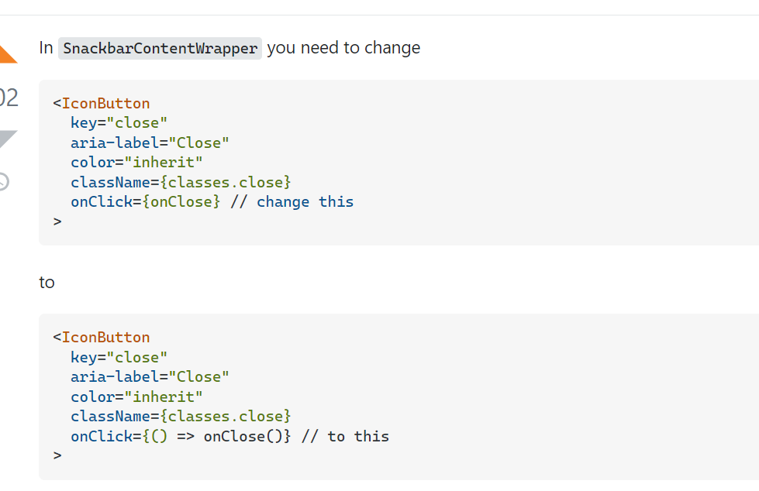  
  
I had my function inside of one of my components like below:

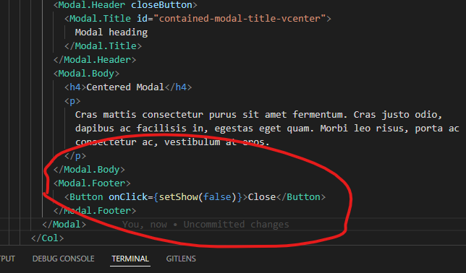  
  
The fix:

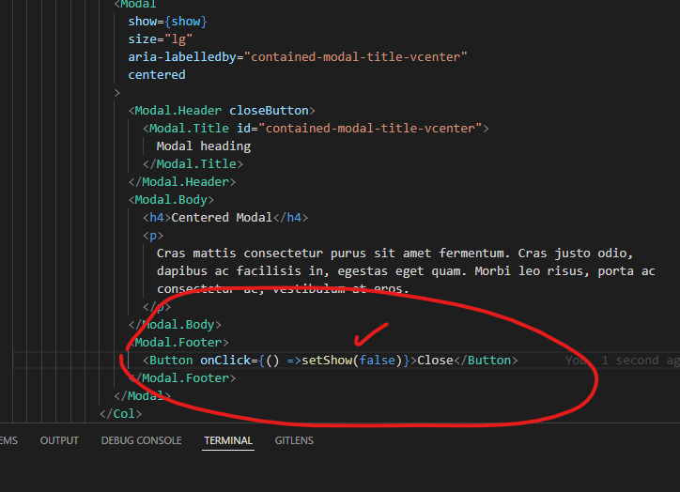  
  
So when you are calling methods inside of one of your components, you have to make sure that the method is already bound, or use the syntax above.

<Button onClick={() =>setShow(false)}>Close</Button>

The reason for this (I saw this before), is because it call the click function without being clicked if you write it like:  
<Button onClick={setShow(false)}>Close</Button>

**It causes an unexpected “re-render” of the DOM**

Here is another example that was broken before I re-wrote the functions as “arrow” functions  
When I was trying to pass props to my child component, and then used a bootstrap button, it kept breaking when I was using a regular function call.

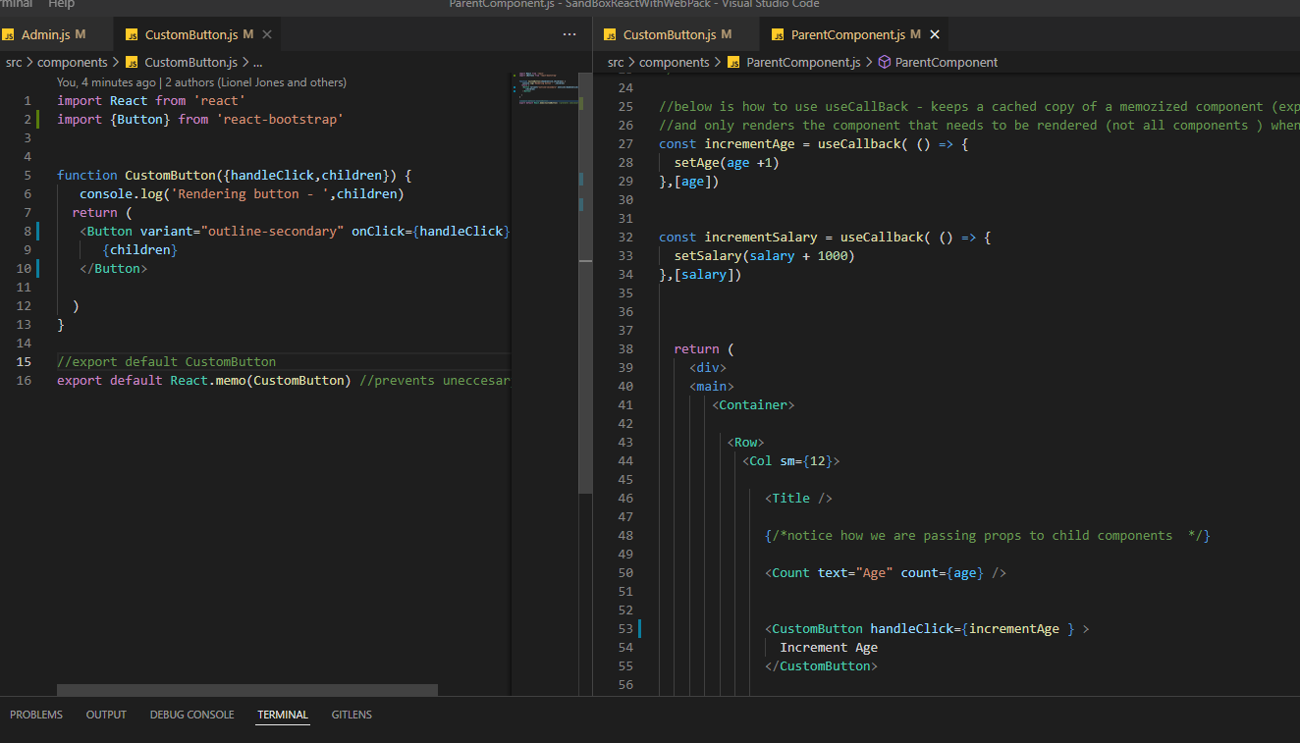

**Topic: REACT FINDINGS – CONCEPTS**

**How React let’s you do an import as an “an”**

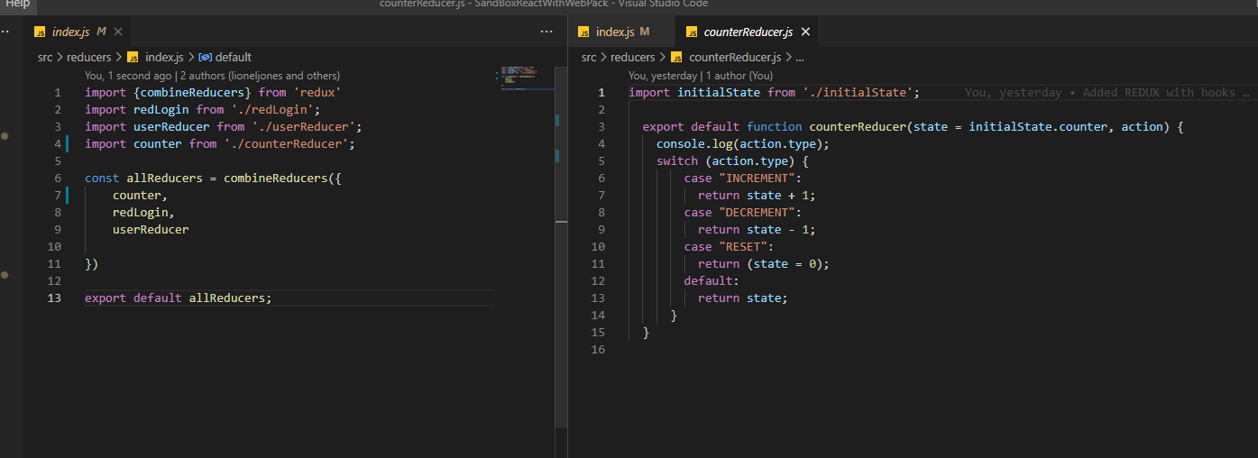  
  
Notice above how you can reference a reducer as an alias without spelling out the actual function name

**FINDINGS – VETTED OUT SNIPPETS**  
  
**Getting the attachment code to work from the Grid**  
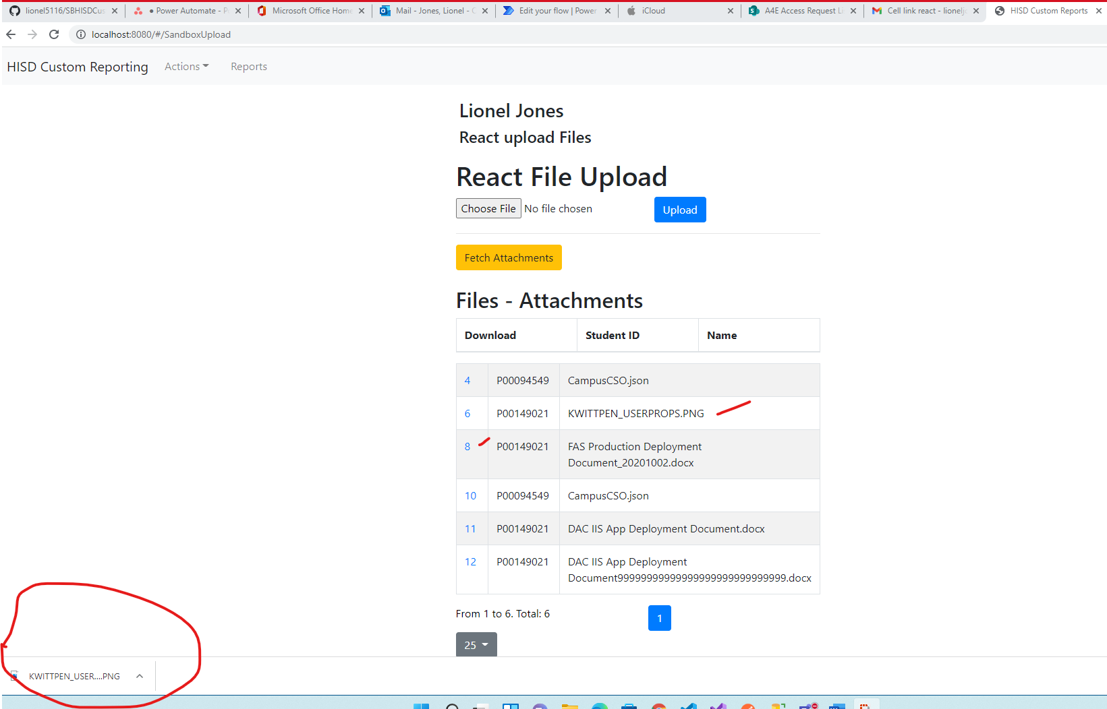  
  
I used a cell formatter

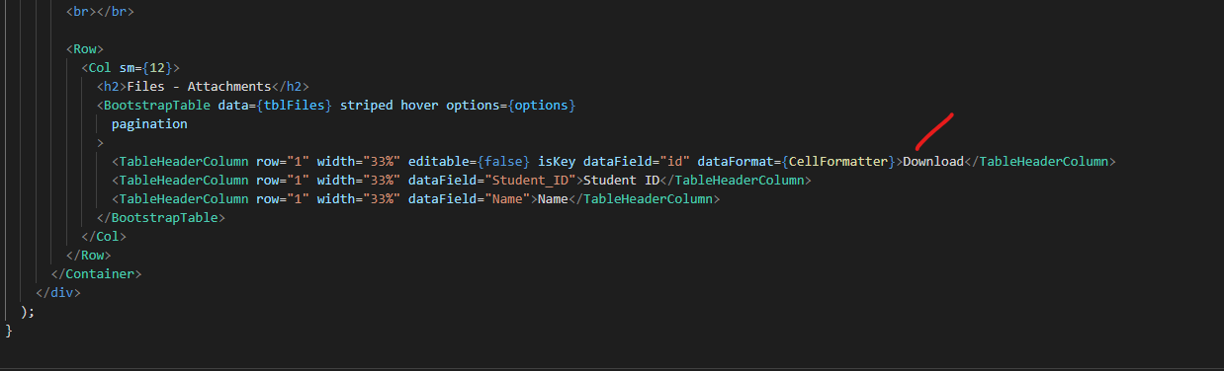  
  
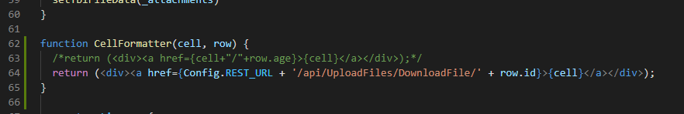  
  
I updated the service with the same code in HISDNutritional Services  
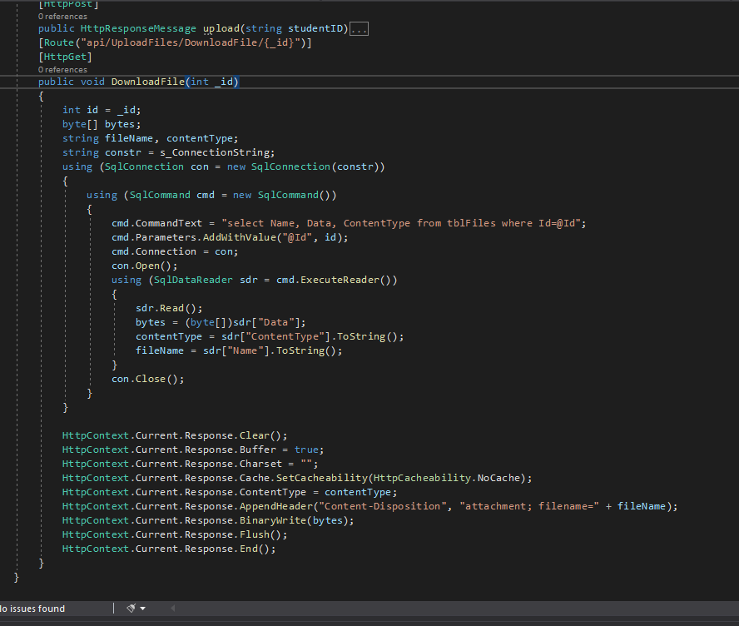  
  
  
**Dialog Boxes:**

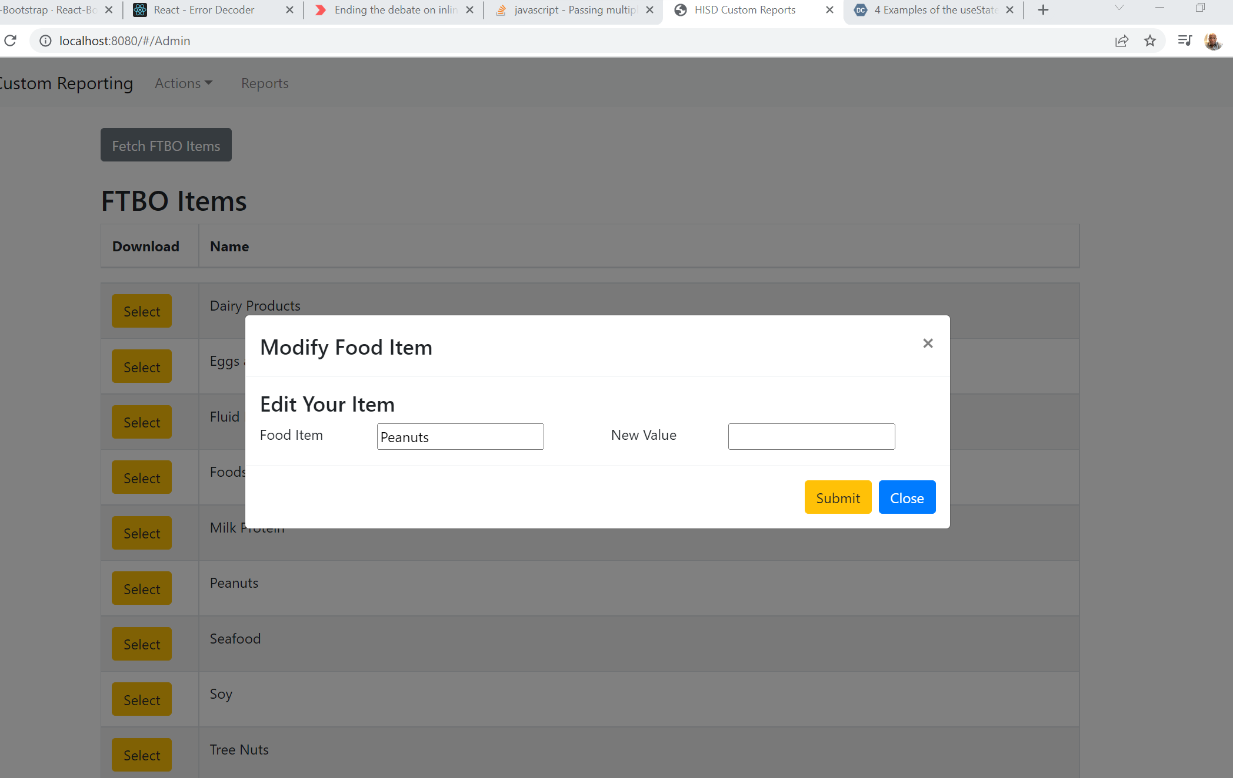

**The traditional Fix (The last resort)**

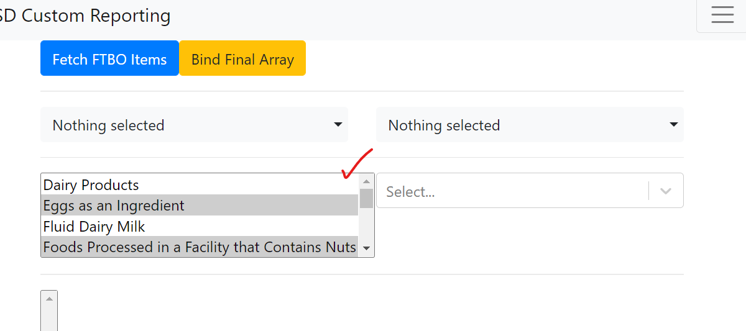

**It is populated by**

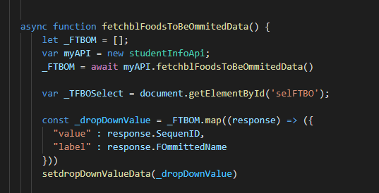

**From useEffect**

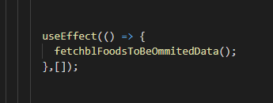

**And getting values is just pure JavaScript**

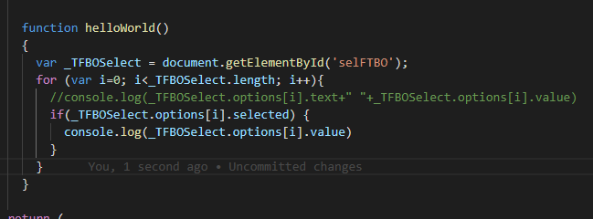

**But with the difficulty of managing adding and removing items, we can use good old traditional JavaScript**

**UPDATE:**You can design “one” component for the dropdowns, make them functional components. Then you can have the component take in props. Based on the props that you pass in will determine what web method to call to bring back the appropriate data (just make it a reusable component).

**Works like a charm**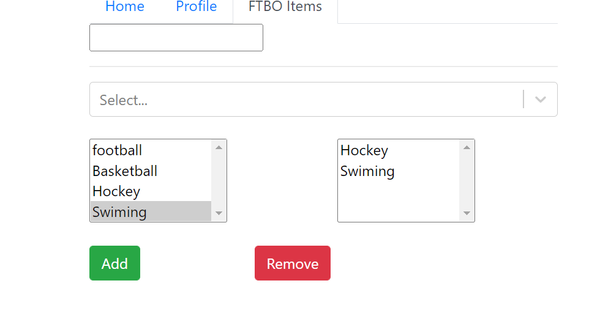

**Multi-Select – The one below is still in investigation (cannot get it work with dynamic)**

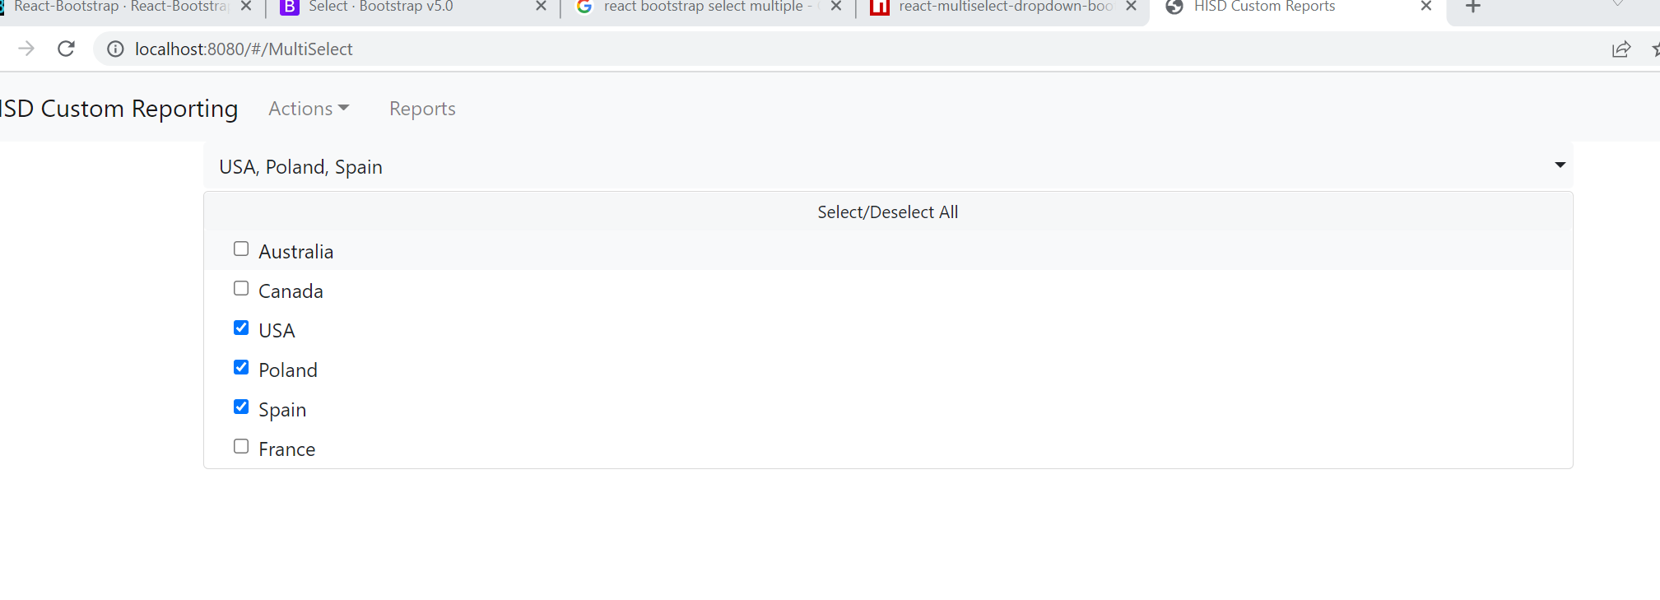<https://www.npmjs.com/package/react-multiselect-dropdown-bootstrap>  
  


Very good docs on the control

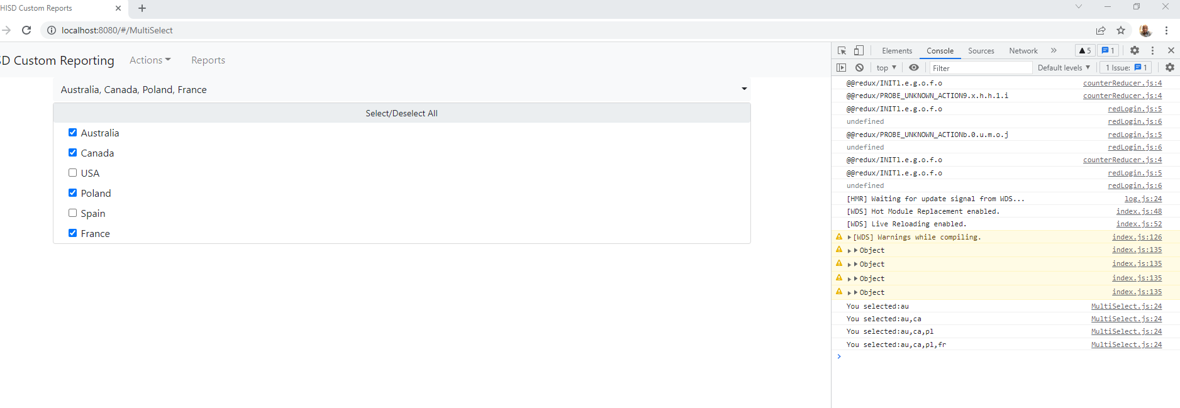

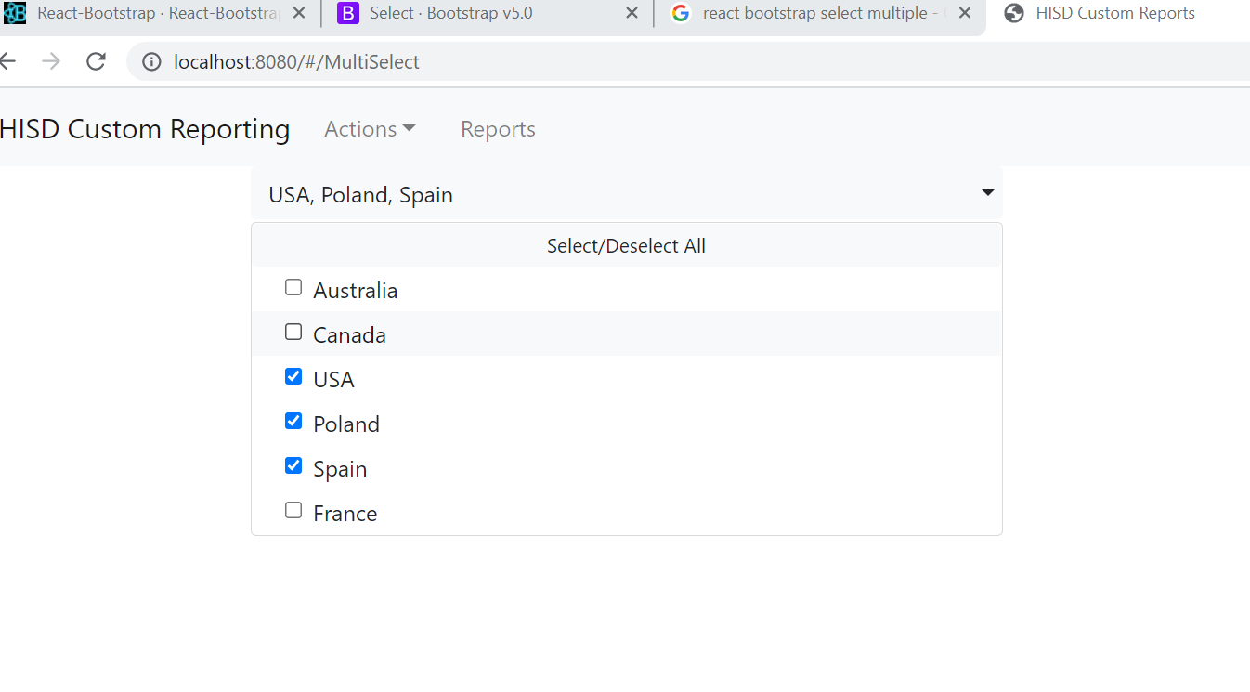

**Topic: HELPER SECTION**

**React Snippets for VSCODE**

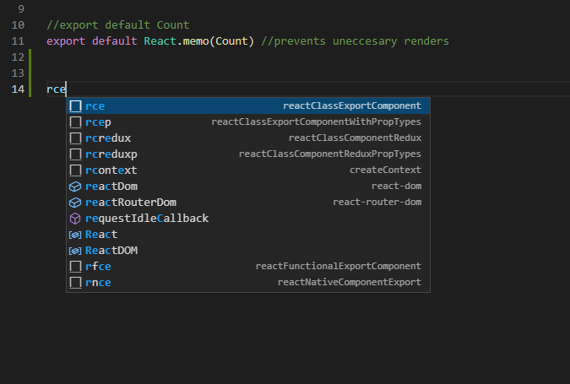

**Stop UseEffect from firing indefinitely**useEffect uses a dependent array, if it not supplied, it will continuously run. Just place an [] array in the function and it will run only once.

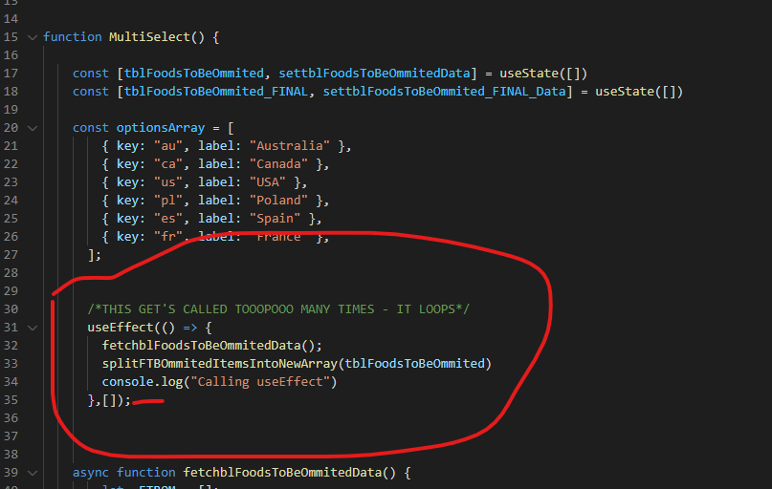

**Boilerplate code for new component**import {Button,

Card,

Container,

Row,

Col,

Image} from 'react-bootstrap';

<div>

<main>

<Container>

<Row>

<Col sm={12}>

</Col>

</Row>

</Container>

</main>

</div>

**Topic: REFERNCE INFO**

**React NPM’s for file-upload**  
<https://www.npmjs.com/package/use-file-upload>  
**React-dropzone-npm  
  
Bootstrap 5 Selects**  
<https://getbootstrap.com/docs/5.0/forms/select/>

<https://react-bootstrap.github.io/forms/select/>  
<https://www.npmjs.com/package/react-multiselect-dropdown-bootstrap>  
<https://stackoverflow.com/questions/54573926/how-to-use-multi-select-dropdown-in-react-bootstrap>

**Topic: Passing data between Parent and Child Components**

https://www.geeksforgeeks.org/how-to-pass-data-from-child-component-to-its-parent-in-reactjs/<https://www.freecodecamp.org/news/pass-data-between-components-in-react/>

**Callbacks**:  
The way that callbacks work is that you are essentially creating a pointer to a method back to your function in your parent component. You are making a “**CALL BACK**” to the parent. In the examples below you will see how you define your actual function/method in your parent component. In your child component (in the case of the custom button example below), the function that we are firing exists in the parent, we then pass a pointer to the props of the child component, the onClick handler uses that pointer to call the function in the parent. This is typical behavior of callbacks in any language. You are making a call back to the parent to satisfy the click event. If you see the example below of SWAV, it is doing the same thing. He is using custom components in the waivers page, the custom components have markup and buttons that have actions that need to be fired, we use callbacks to make the function calls on the parent.  
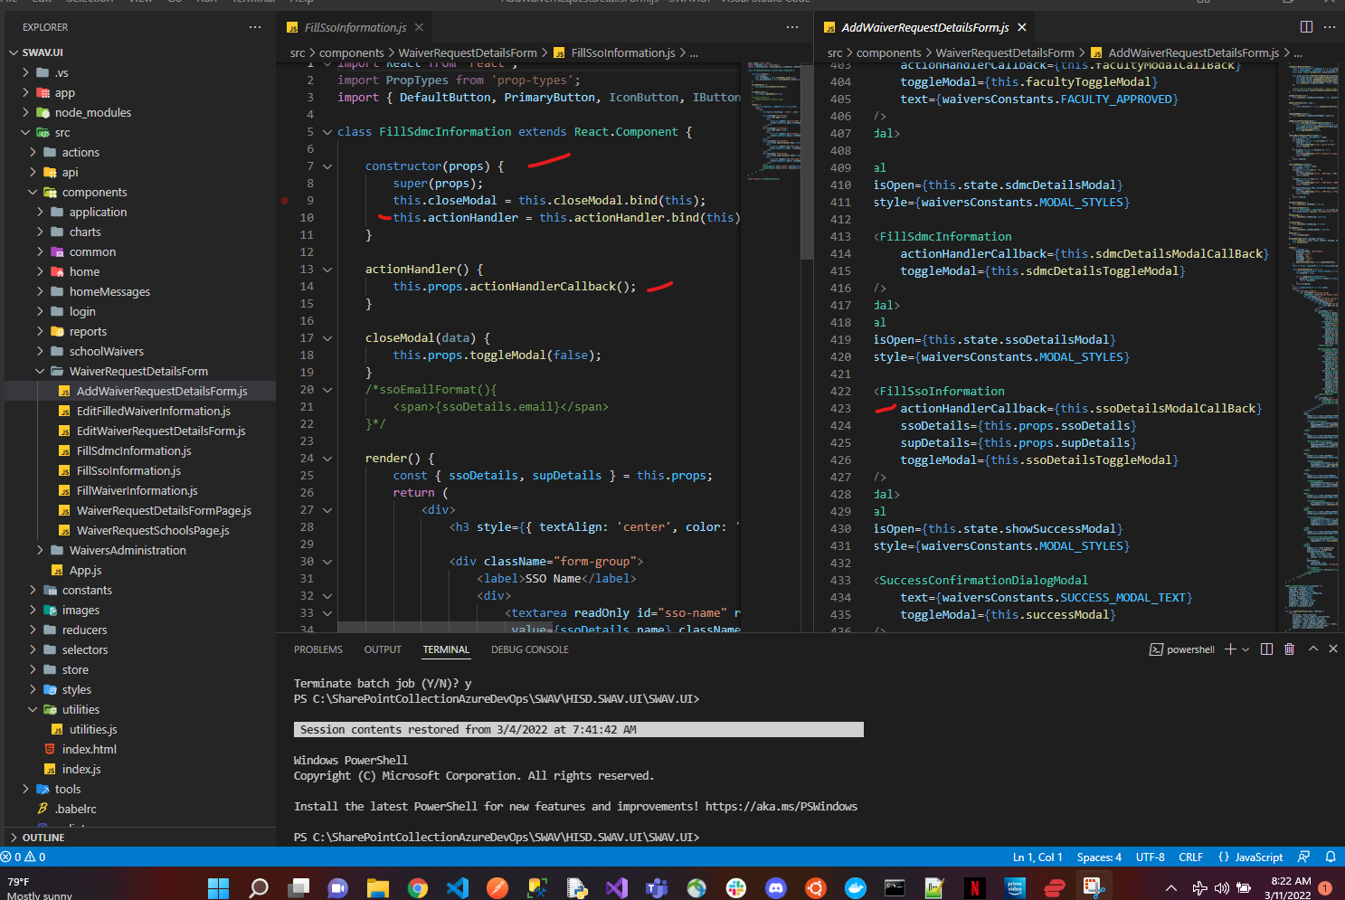  
  
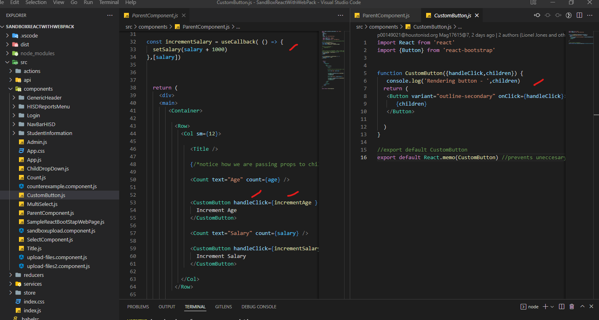

How to pass an array as props to a component

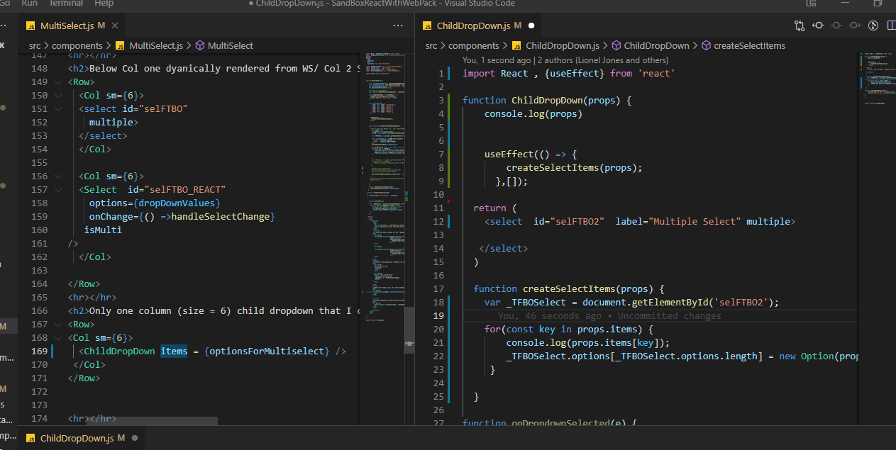

And it works – Notice how have to pass in the props as items = {data}, then when accessing the data, we have to refer to it as: props.items, I had the hardest time figuring this out

<https://www.youtube.com/watch?v=H3pfPzpMZQM>

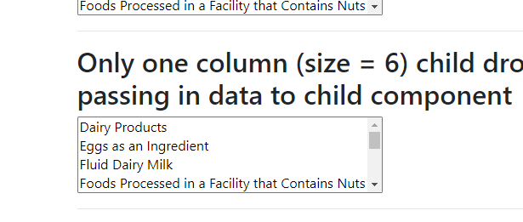

**Getting the application to work with a Python Flask API**  
First I created a project (Python Flask Project)  
  
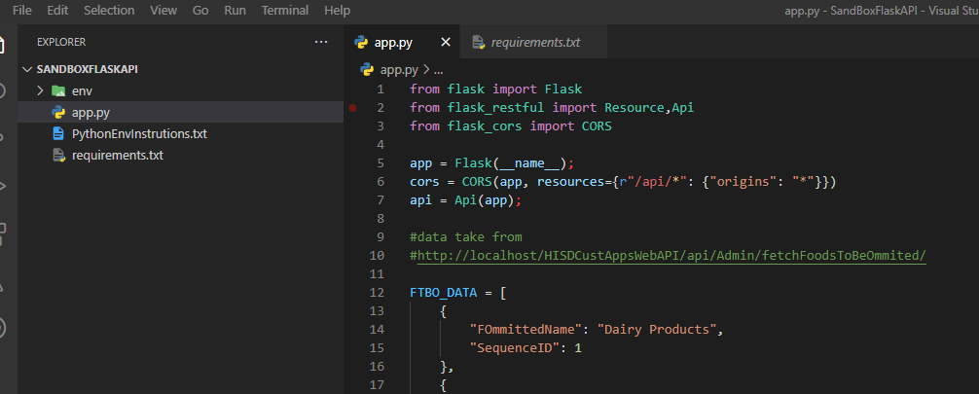  
  
Getting the CORS issue fixed to work with a call from my React App  
First install the dependency:  
from flask_cors import CORS

Then use the line below:  
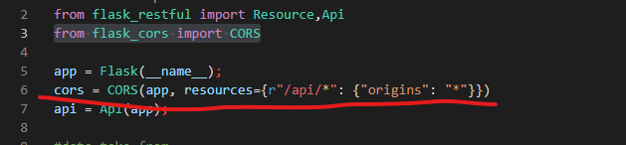  
  
For your API



Then just fire up your service:

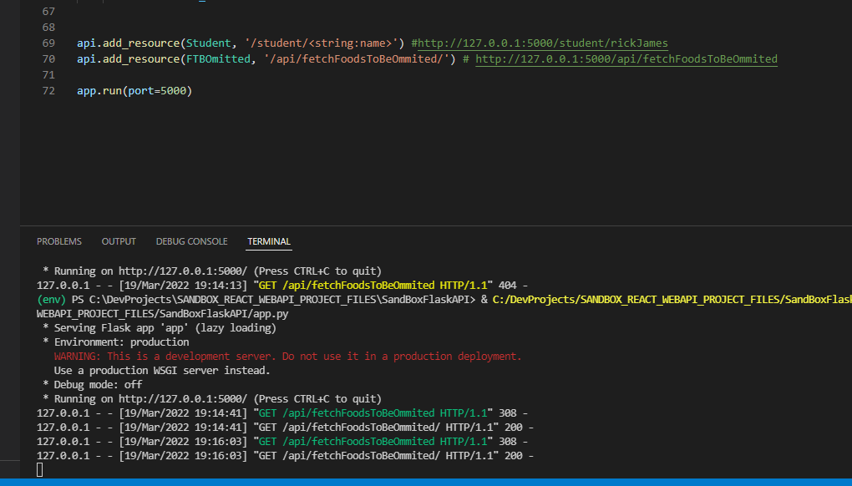

Call your endpoint from your React App

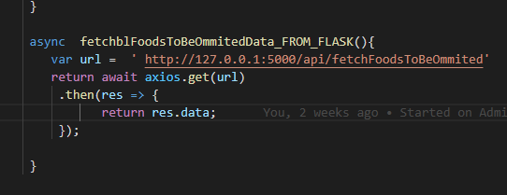

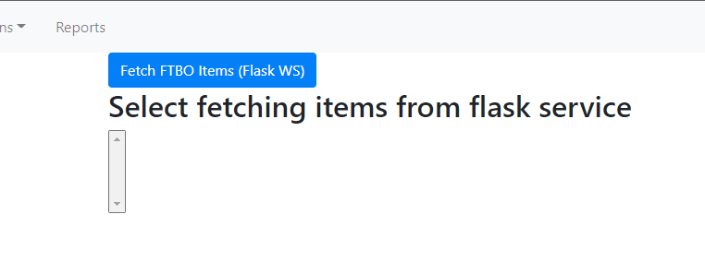  
  
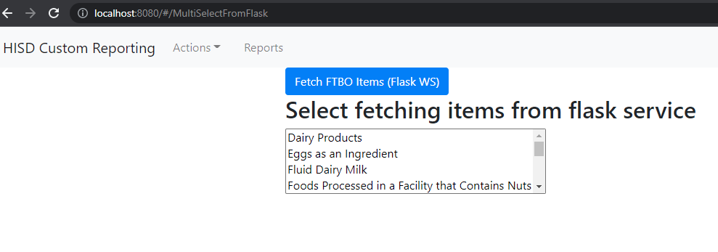

There is also pip freeze information as well (for using the Python Project with it’s own requirement.txt) file and env

**Topic: Installing MYSQL on Mac**

<https://www.youtube.com/watch?v=n1zT1OZcgnw>  
All you have to do is go to the mySQL site and download the latest community version.  
When you try to install and get a “open application from unidentified developer”, go to System Settings->Security and privacy  
  
Select the community server edition, Select the 8.8.28 arm64 edition for your Macbook Air. The installation will prompt for enhanced or legacy password, I selected legacy. It also prompts for password for root, I used

BFLU@

After installation was complete, I went to System Preferences to see whether it was running or not:  
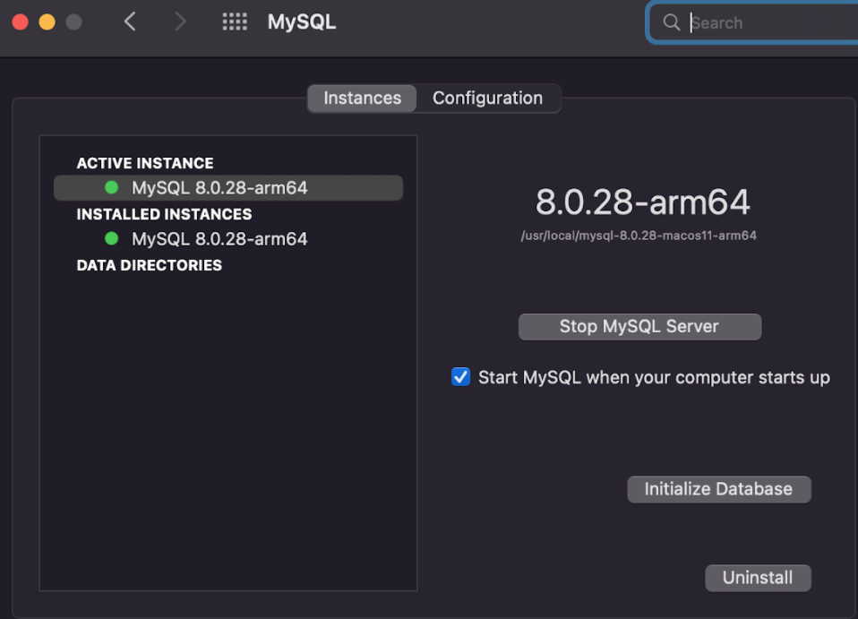  
  
  
The client you will be using is:  
<https://www.youtube.com/watch?v=SVNbRXUEDUg>  
phpAdmin  
  
After you have installed MySQL, you can create a new user:  
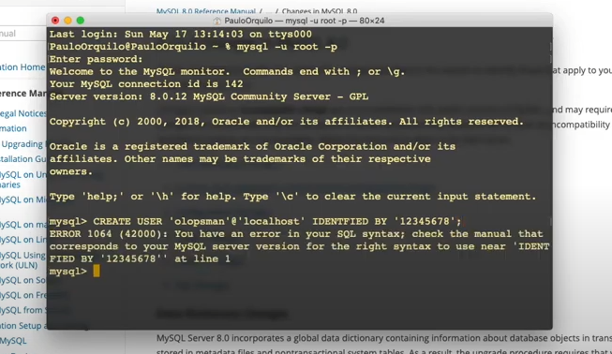  
  
**Setting the root password for MYSQL**  
https://stackoverflow.com/questions/6474775/setting-the-mysql-root-user-password-on-os-x

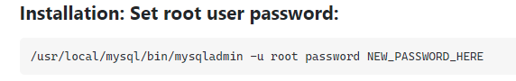  
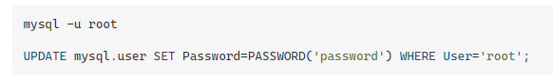

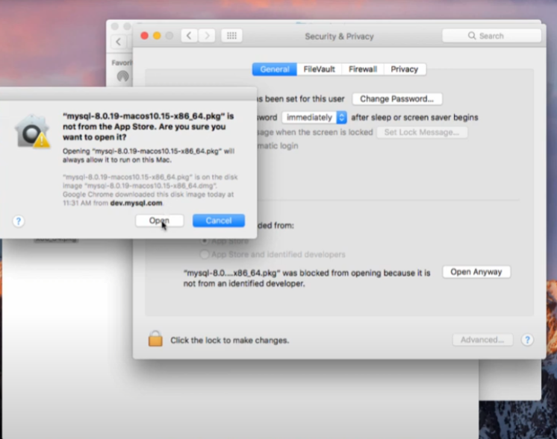  
  
To get the path to work with MSQL on M1  
Instructions are here:

Setting your path after installation  
<https://www.youtube.com/watch?v=oxToe-4c6OM>  
It's different for M1  
  
You essentially have to get your  
.zprofile to look like:  
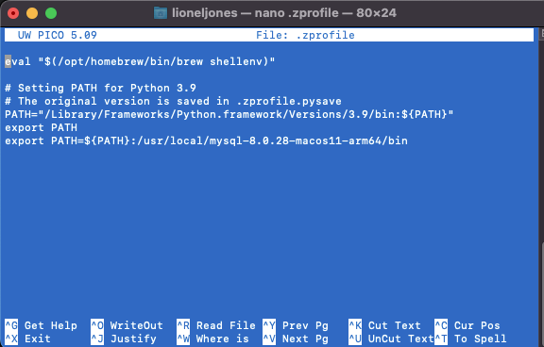  
  
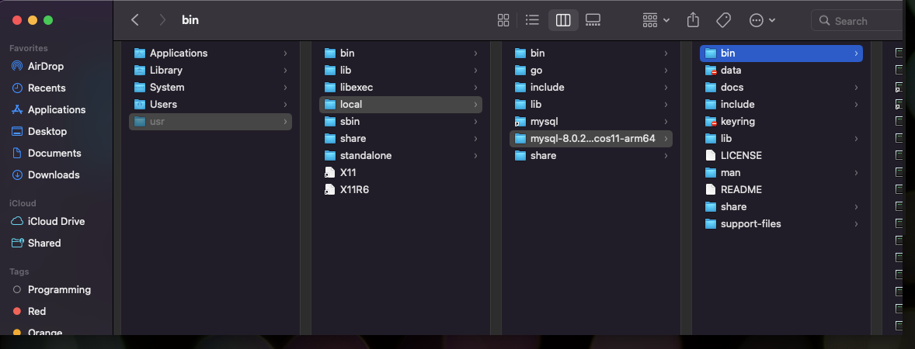  
  
Afterwards:  
go to a new terminal window:  
mysql -u root -p  
and type your password  
to quit mysql  
exit;  
  
Installing MYSQL Workbench for creating schemas/ queries etc:

<https://dev.mysql.com/downloads/file/?id=509437>  
  
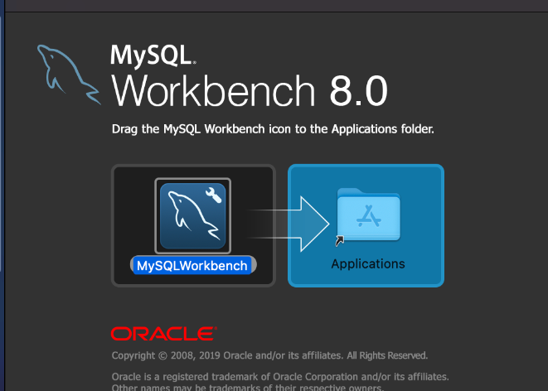  
  
When you connect, you can create a schema (A Schema is a Database)  
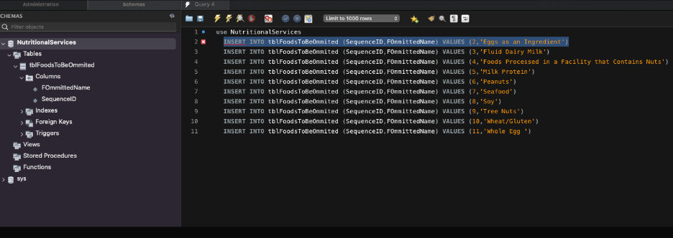  
  
Create a table:  
Afterwards, you can log into terminal and view databases

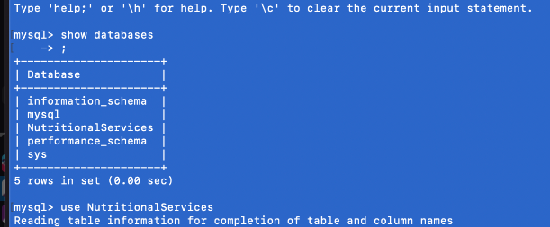

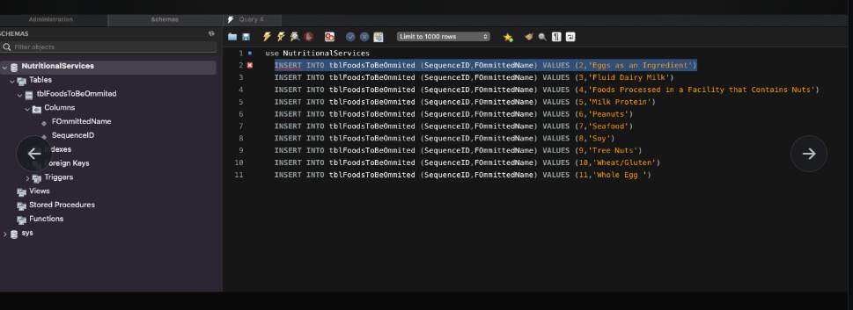  
  
After you have inserted record:  
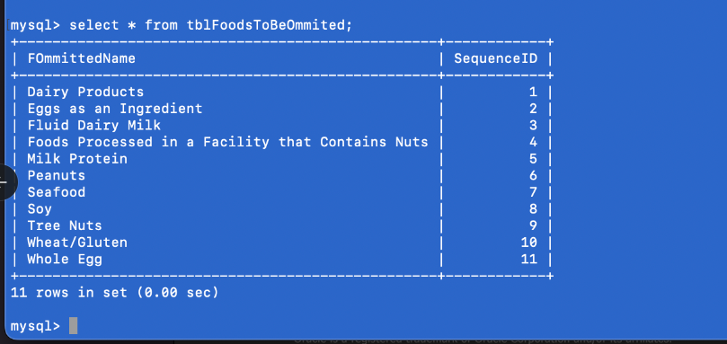  
  
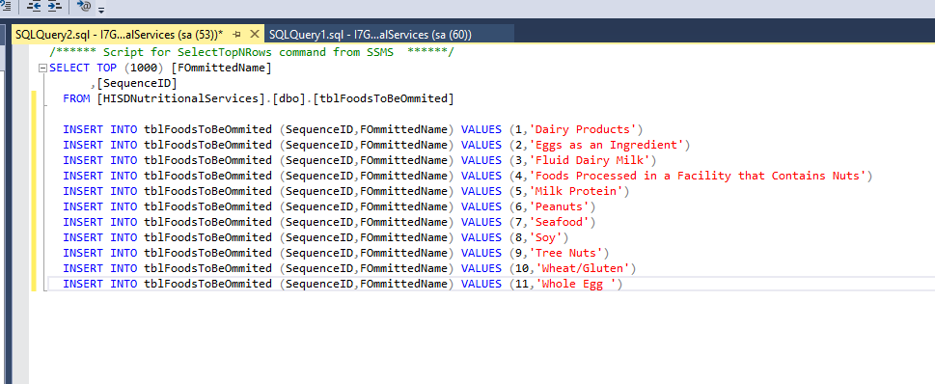  
  
INSERT INTO tblFoodsToBeOmmited (SequenceID,FOmmittedName) VALUES (1,'Dairy Products')

INSERT INTO tblFoodsToBeOmmited (SequenceID,FOmmittedName) VALUES (2,'Eggs as an Ingredient')

INSERT INTO tblFoodsToBeOmmited (SequenceID,FOmmittedName) VALUES (3,'Fluid Dairy Milk')

INSERT INTO tblFoodsToBeOmmited (SequenceID,FOmmittedName) VALUES (4,'Foods Processed in a Facility that Contains Nuts')

INSERT INTO tblFoodsToBeOmmited (SequenceID,FOmmittedName) VALUES (5,'Milk Protein')

INSERT INTO tblFoodsToBeOmmited (SequenceID,FOmmittedName) VALUES (6,'Peanuts')

INSERT INTO tblFoodsToBeOmmited (SequenceID,FOmmittedName) VALUES (7,'Seafood')

INSERT INTO tblFoodsToBeOmmited (SequenceID,FOmmittedName) VALUES (8,'Soy')

INSERT INTO tblFoodsToBeOmmited (SequenceID,FOmmittedName) VALUES (9,'Tree Nuts')

INSERT INTO tblFoodsToBeOmmited (SequenceID,FOmmittedName) VALUES (10,'Wheat/Gluten')

INSERT INTO tblFoodsToBeOmmited (SequenceID,FOmmittedName) VALUES (11,'Whole Egg ')  
  
A good Video Series (with sample MSSQL Scripts for creating your content)  
<https://www.youtube.com/watch?v=7S_tz1z_5bA>

**Getting Props to Work with Reusable Controls**  
Along with Reusable Components  
In my project, I was building a search screen. On the search screen, there was a select control that I needed to use multiple times. The only gotcha was, I needed the ID to be different for each select and have a re-usable control.

This was solved by:  
First creating a reusable select control  
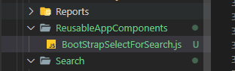  
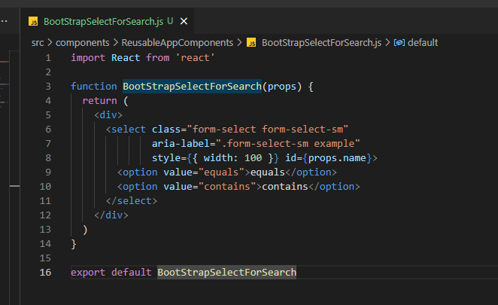  
  
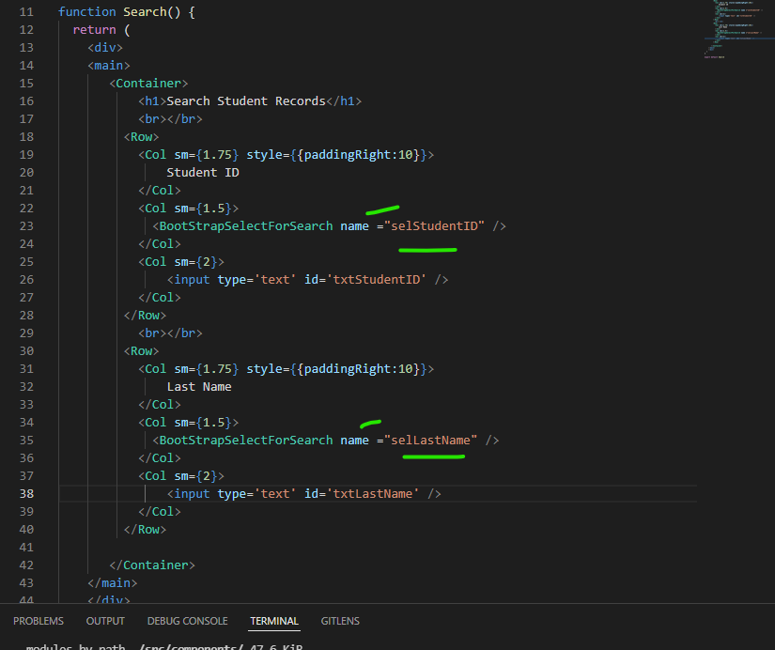  
  
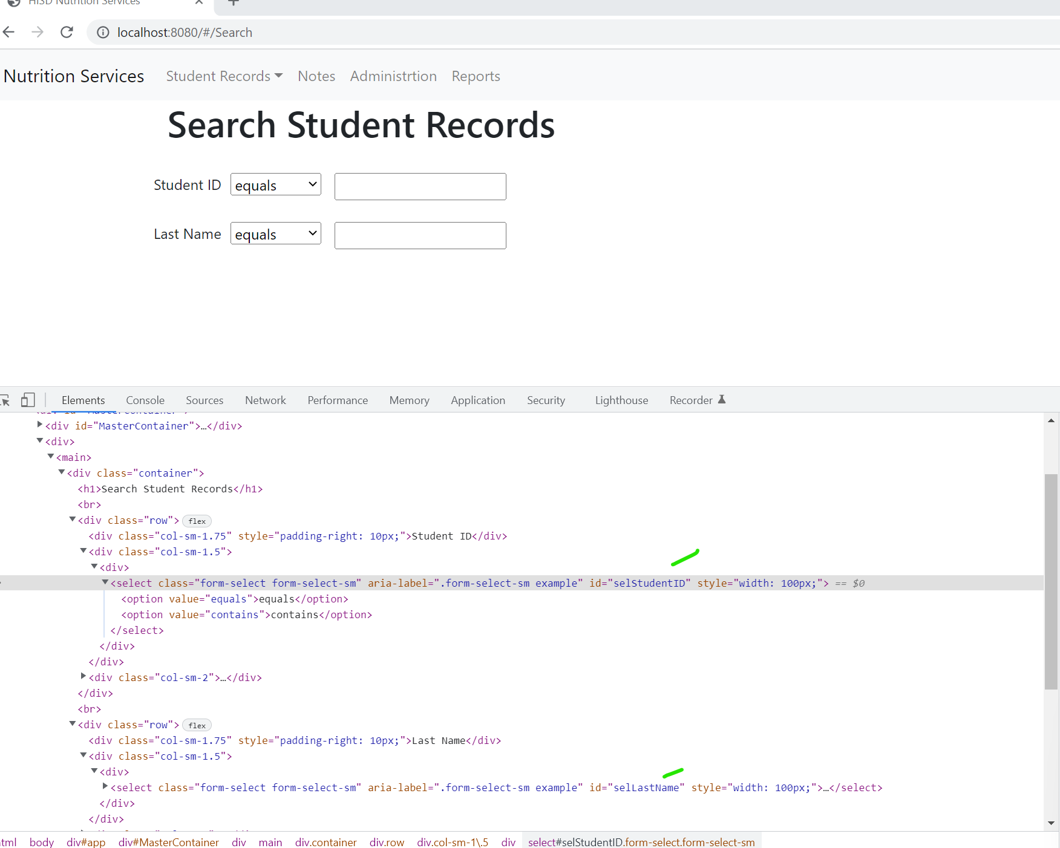  
  
And as you can see, I am passing in the props for the ID and it works.  
This was taken from the React Docs  
<https://reactjs.org/docs/components-and-props.html>

This was also proven in this project as well between the:  
MultiSelect.js and ChildDropDown.js components for passing in data fetched from a WS Call and passed to the child component.

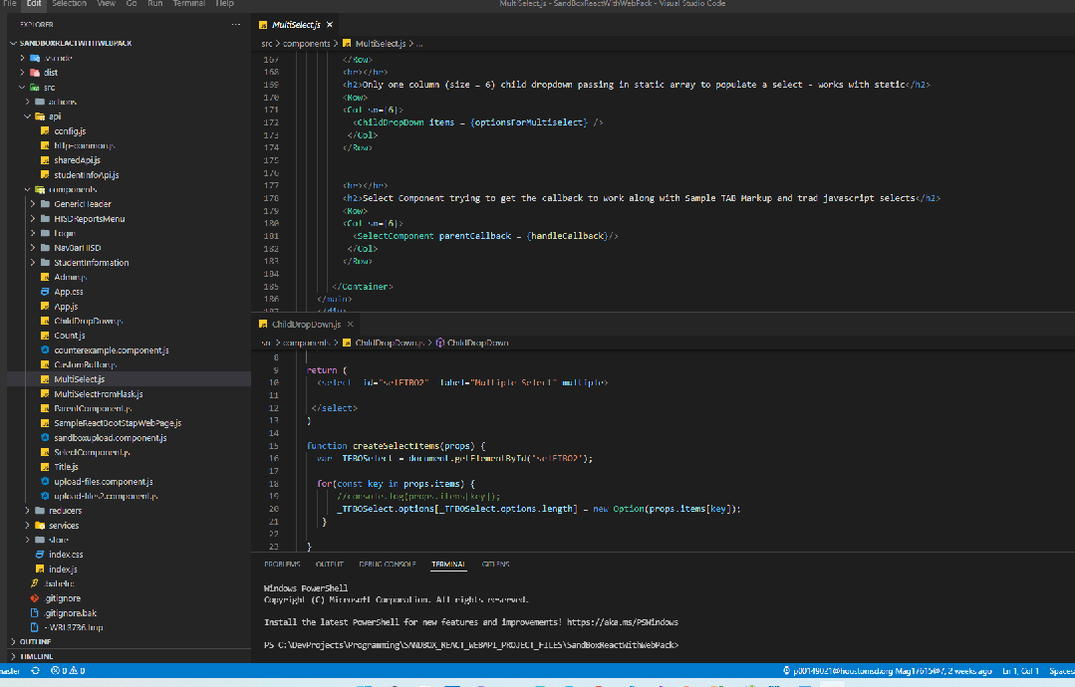  
<https://react-bootstrap-table.github.io/react-bootstrap-table2/>

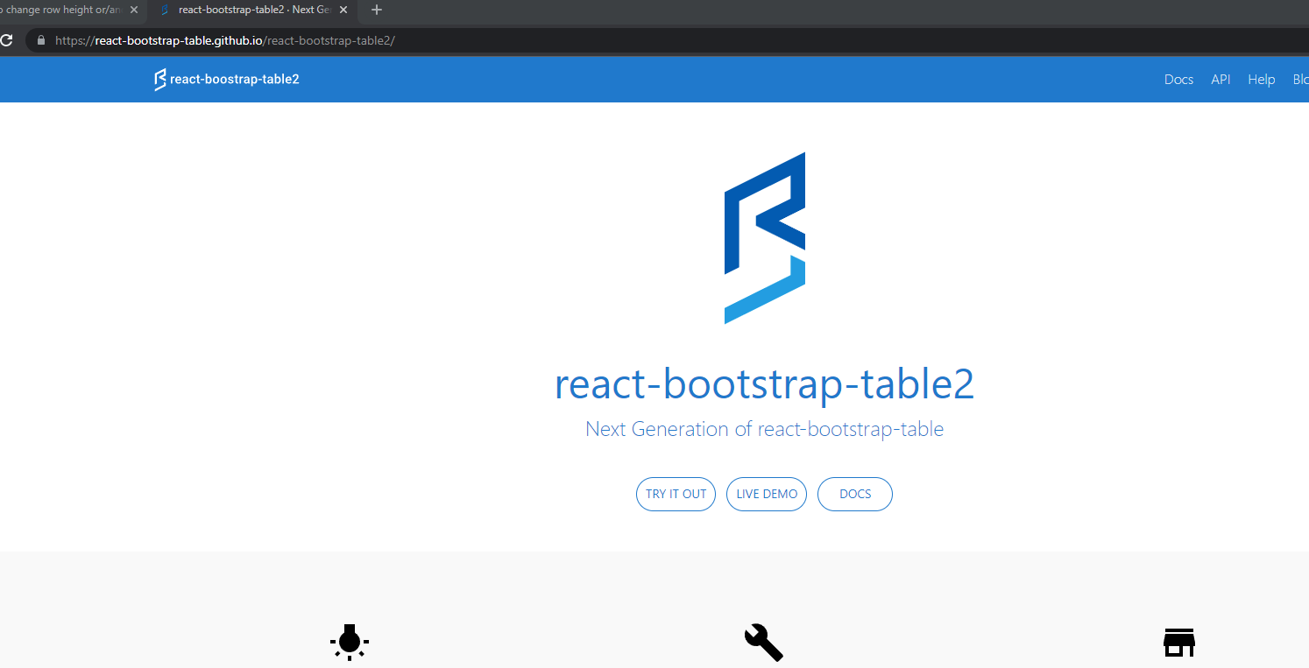

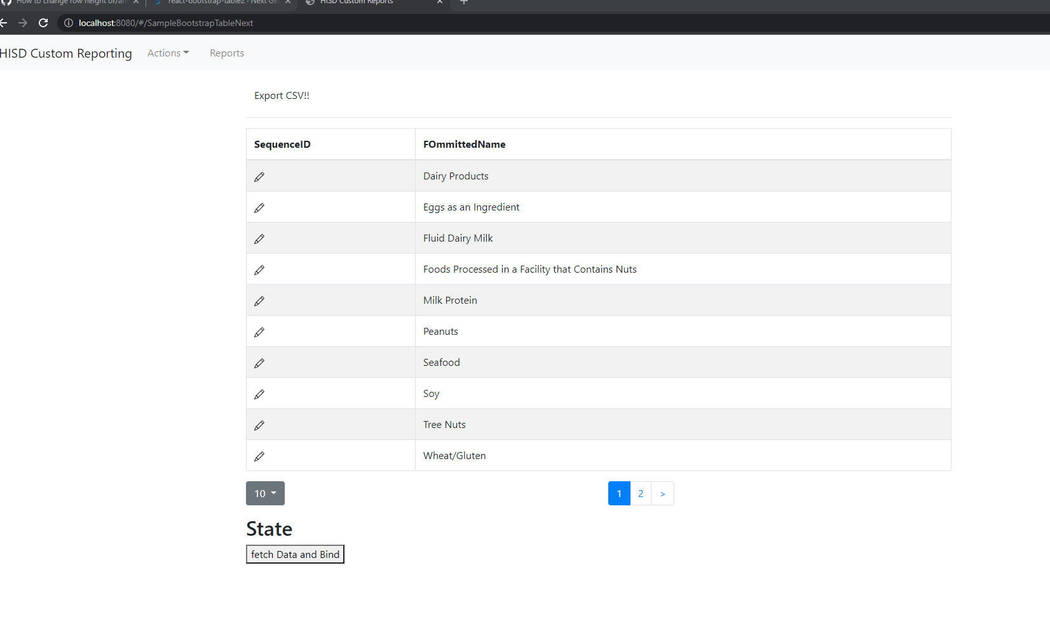

**Topic**: Controlled Form Example (With Bootstrap Styling)

This is from this article  
<https://medium.com/swlh/building-controlled-forms-using-functional-components-in-react-965d033a89bd>  
The layout for bootstrap is from

<https://react-bootstrap.github.io/forms/layout/>

**This example outlines:**  
How to use the built-in date formatter using html-5 (as opposed to jquery)  
How to use the spread operator (ControlledFormParent.js)  
How to pass props from parent to child  
Callback to the parent from a deconstruction with react  
Using react bootstrap form control for clean layout

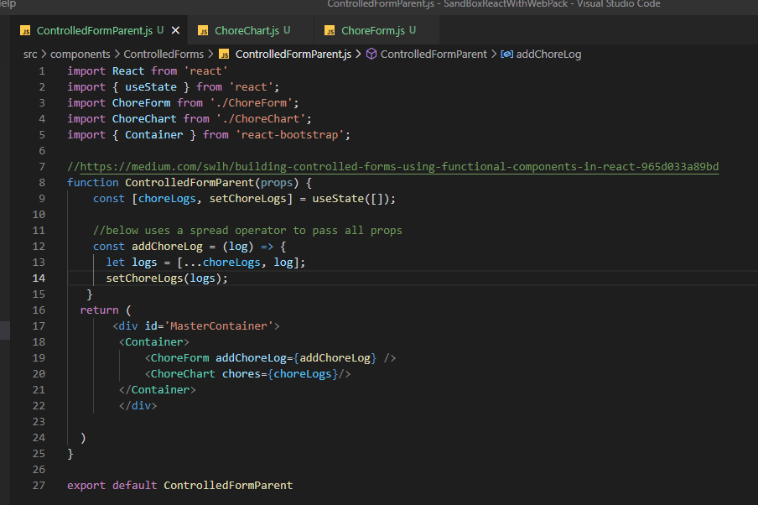  
  
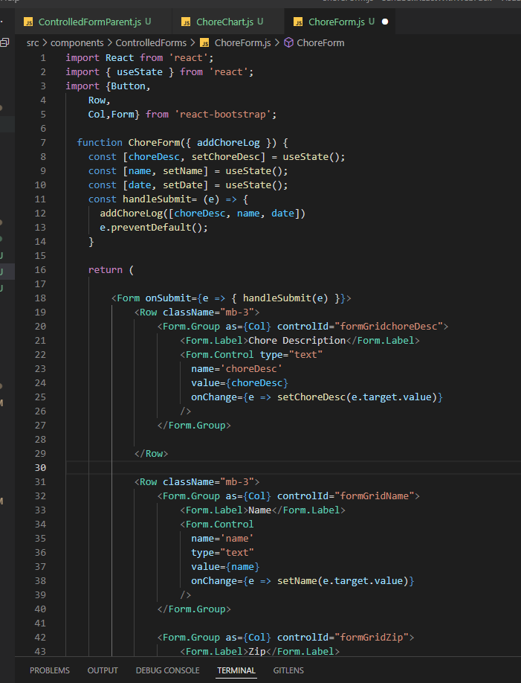

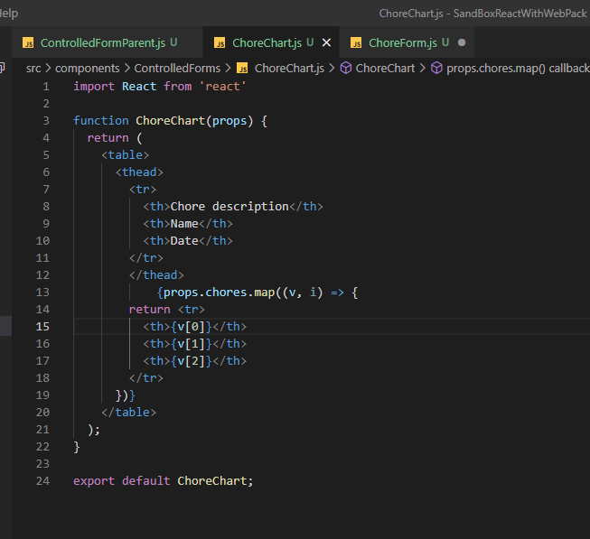

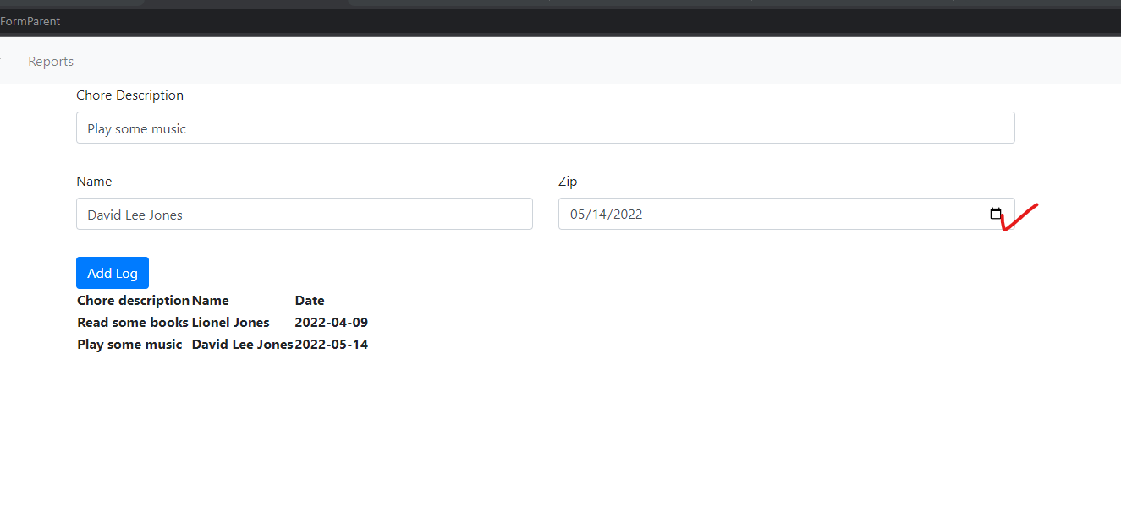

**Topic**: Controlled Form using an object with UseState  
I did not finish up the validation part because I just wanted to get using and object with useState  
This was taken from  
<https://www.dotnetcurry.com/reactjs/forms-using-react-functional-components-hooks>  
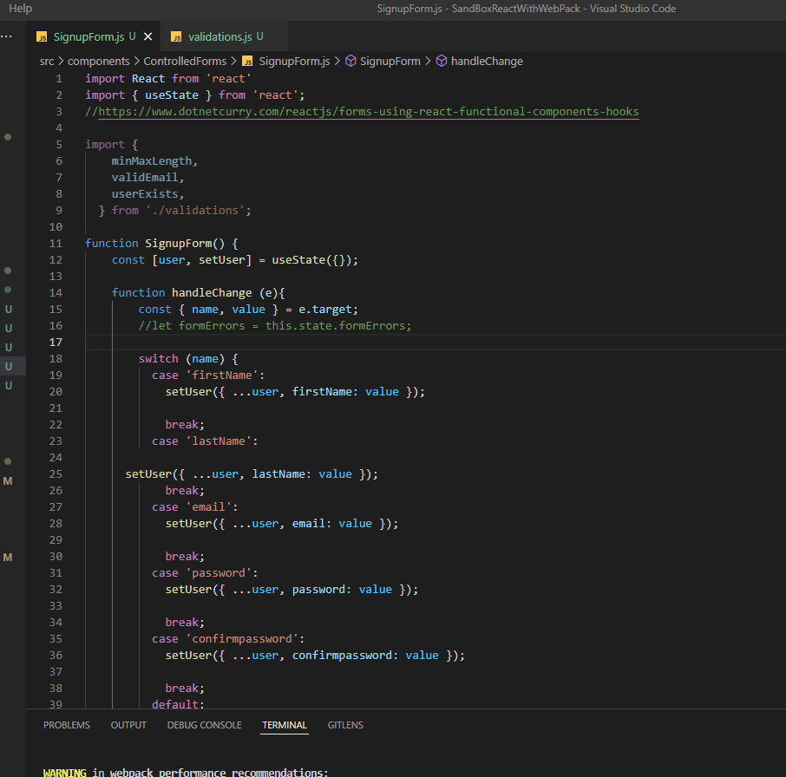  
  
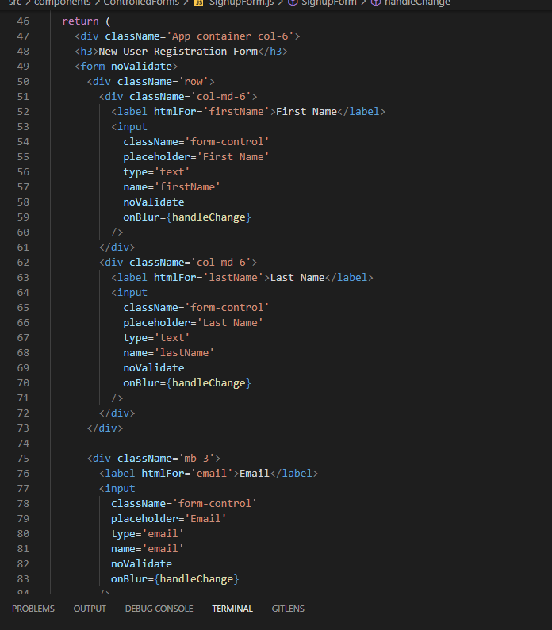  
  
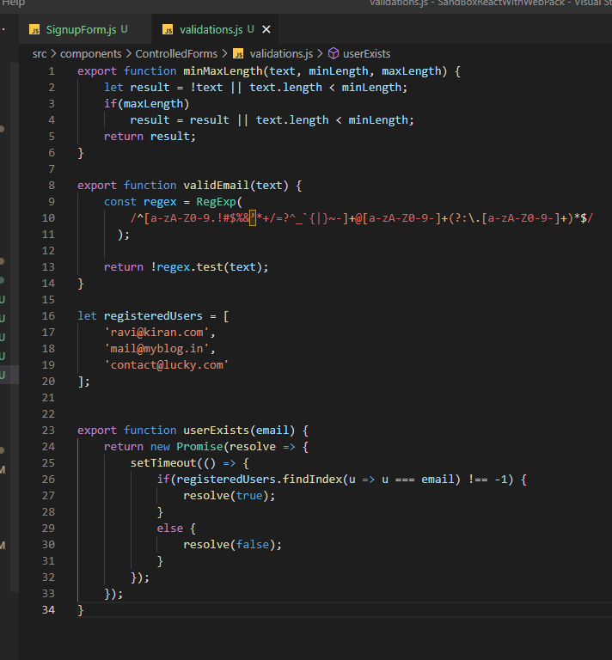

And here is the result

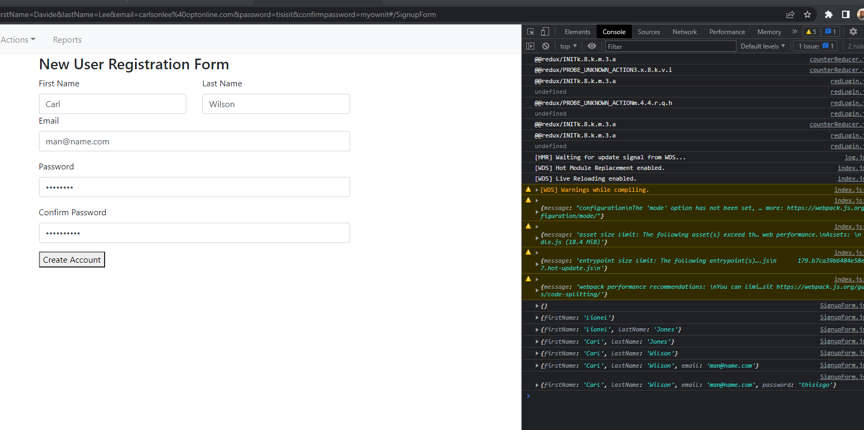

As you can see, when you move your mouse cursor from the field , it fires the function onHandlechange and set’s the user objects properties and builds the object that can be later pass to a update or add method

**Topic**: Error with Form.Select with Webpack  
https://react-bootstrap.github.io/forms/layout/  
Taken from the form on bootstrap react website

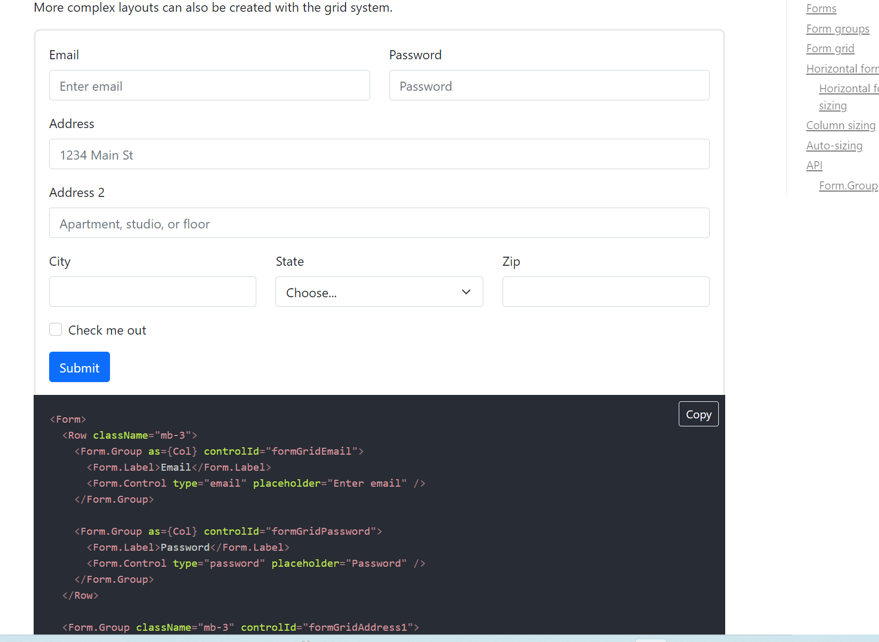

<Form.Group as={Col} controlId="formGridState">

<Form.Label>State</Form.Label>

**<Form.Select** defaultValue="Choose...">

<option>Choose...</option>

<option>...</option>

</Form.Select>

</Form.Group>

Webpack does not like :  
 <Form.Select  
  
When it compiles you get the following error  
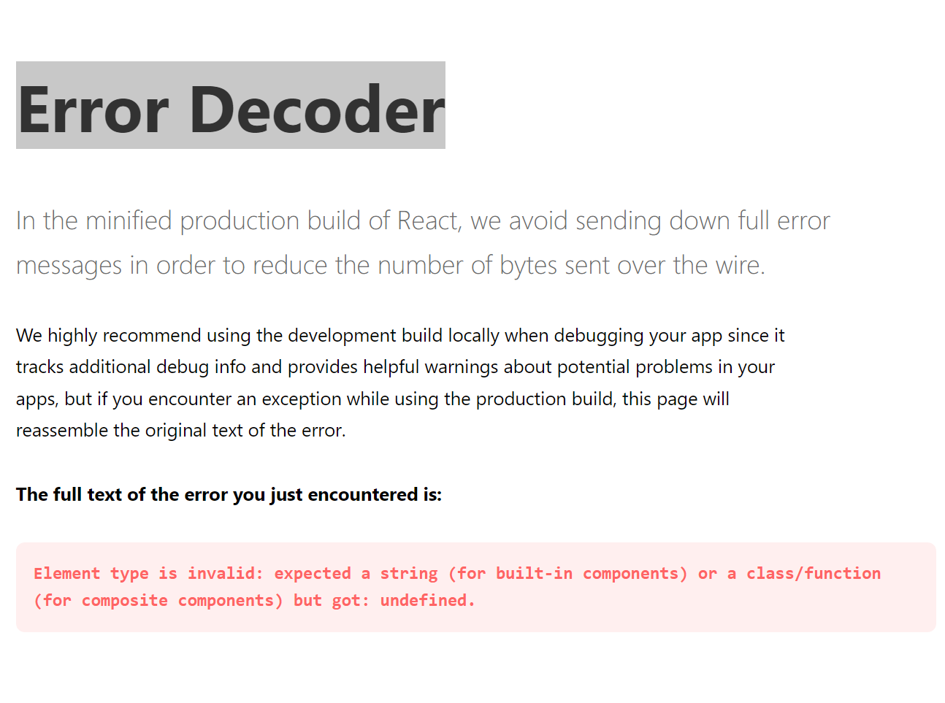  
The way to fix it is to use:  
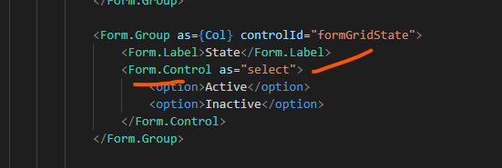  
  
<https://stackoverflow.com/questions/68166687/why-isnt-form-select-recognized-in-my-simple-react-bootstrap-app-following-the>

**Topic**: Building a complex form with useState Object  
Control:  
ComplexForm.js  
This is a good approach because it uses an object with useState

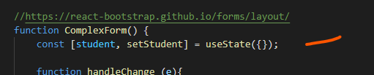  
  
And you are dynamically building the state object’s field/values using the setState hook

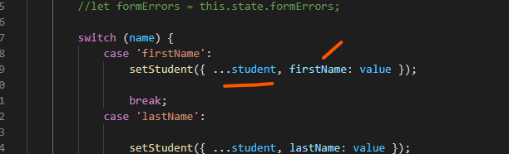  
  
Look at the syntax as well as it uses the spread operator in es6  
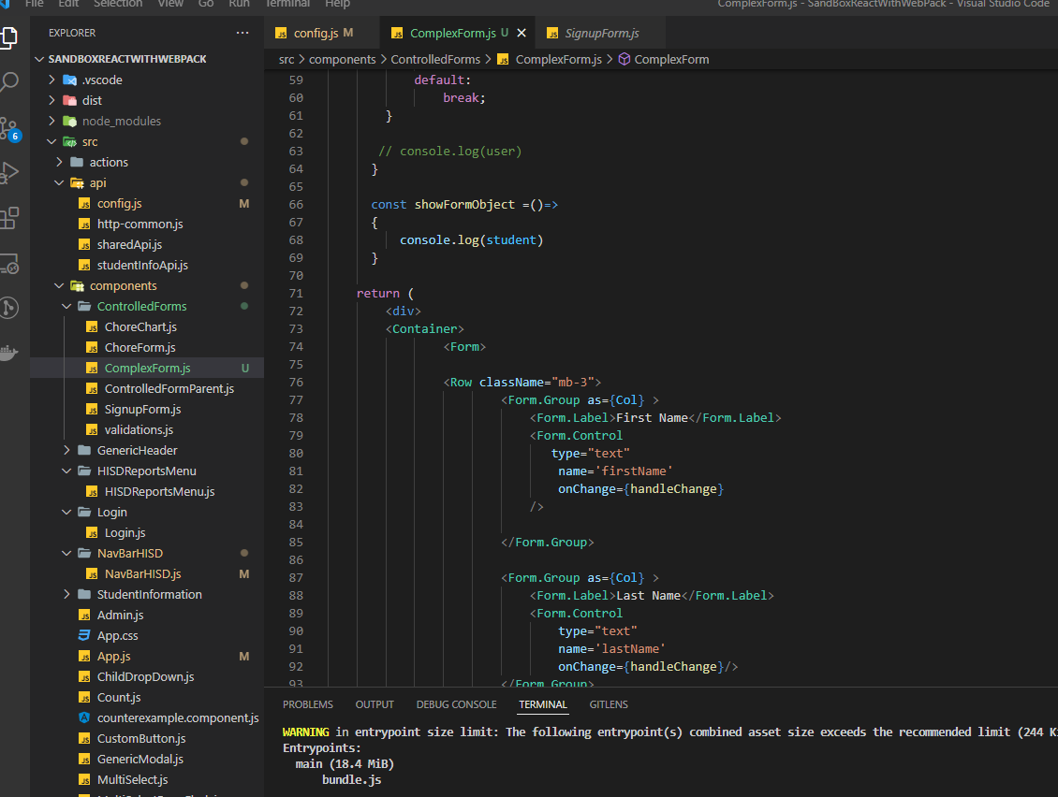  
  
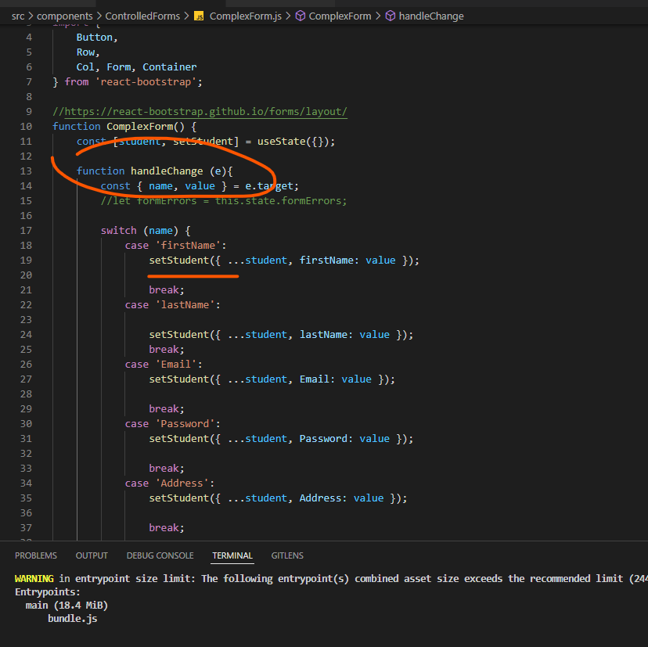  
  
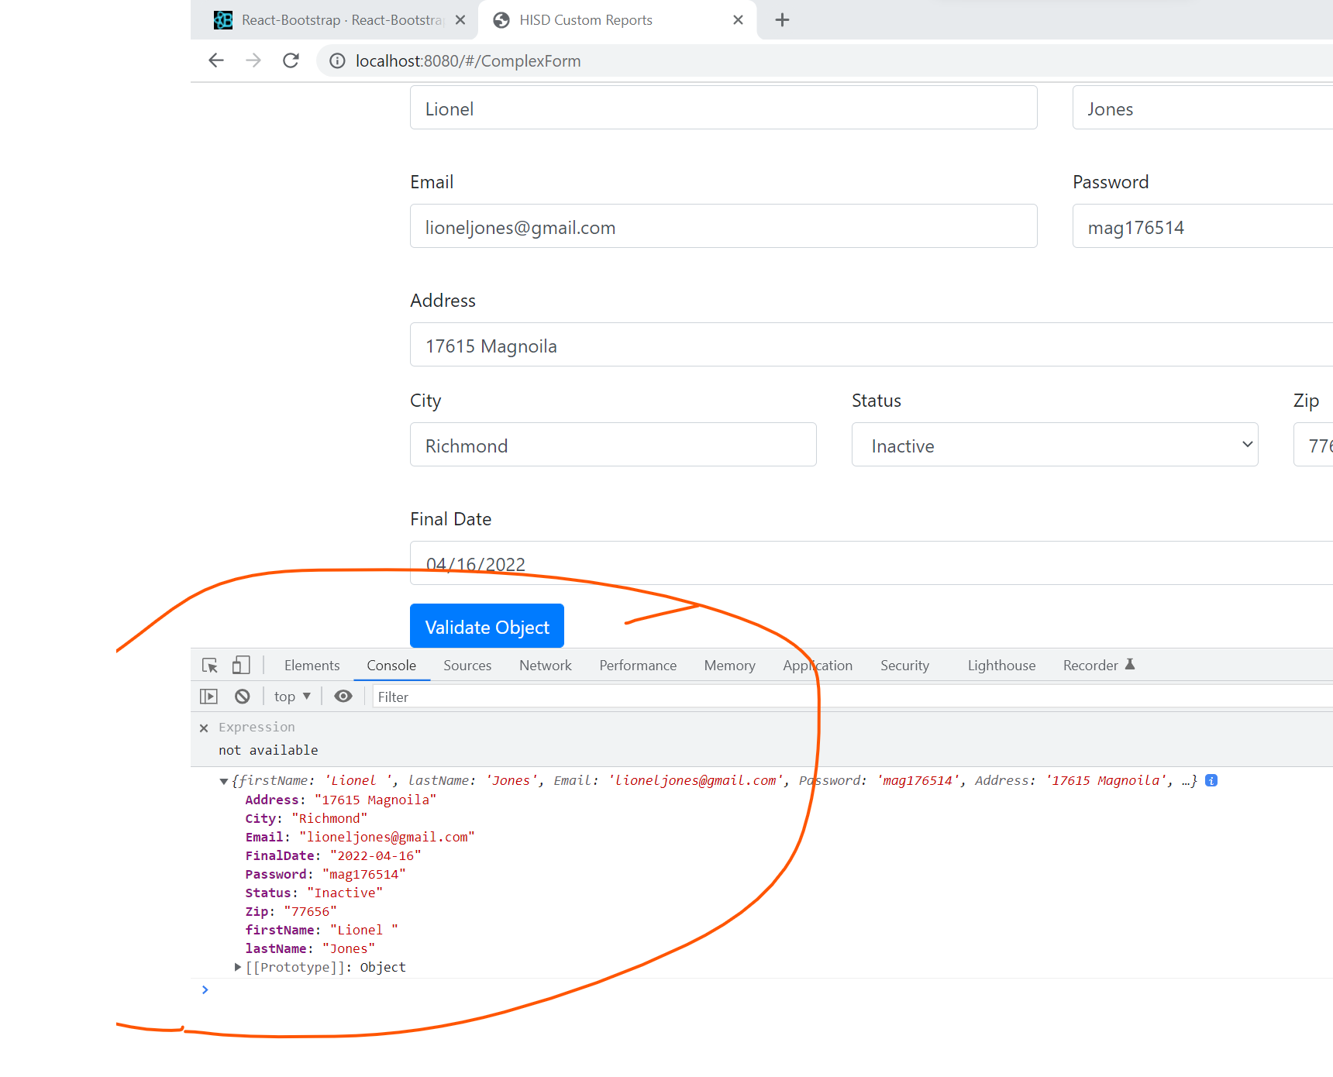

The article below explains how to use useState with an predefined object

<https://stackoverflow.com/questions/59813926/usestate-to-update-multiple-values-in-react>  
  
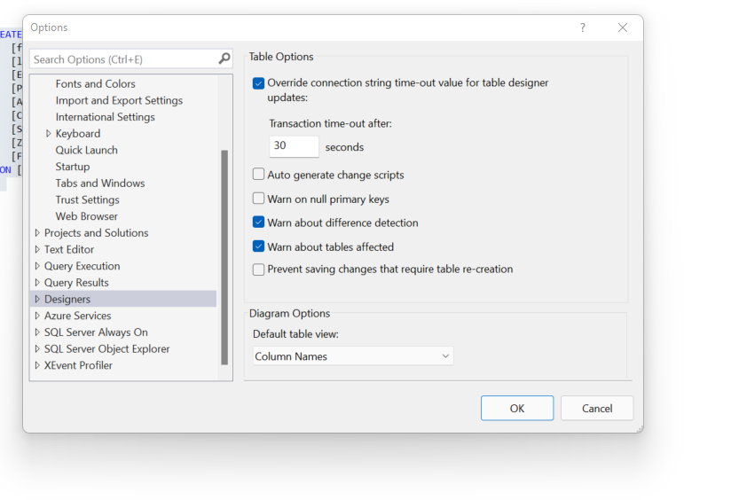  
  
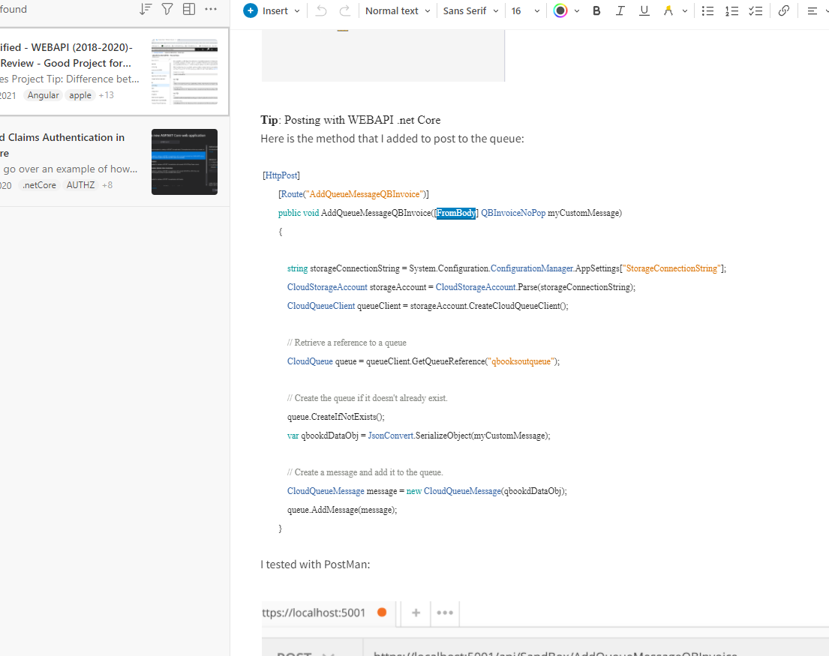

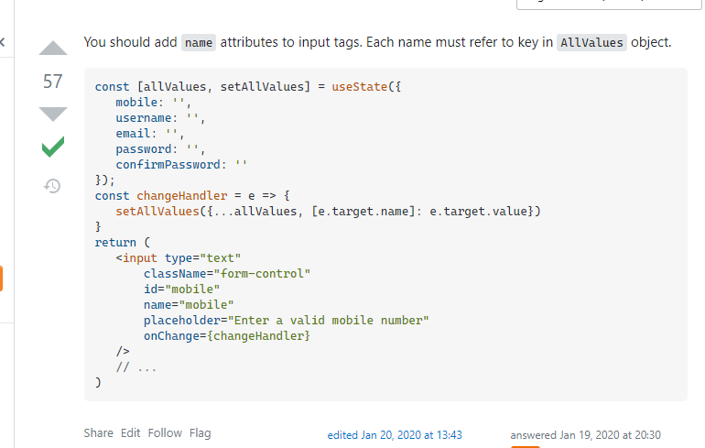  
  
It explains how to leverage the spread operator  
https://daveceddia.com/usestate-hook-examples/

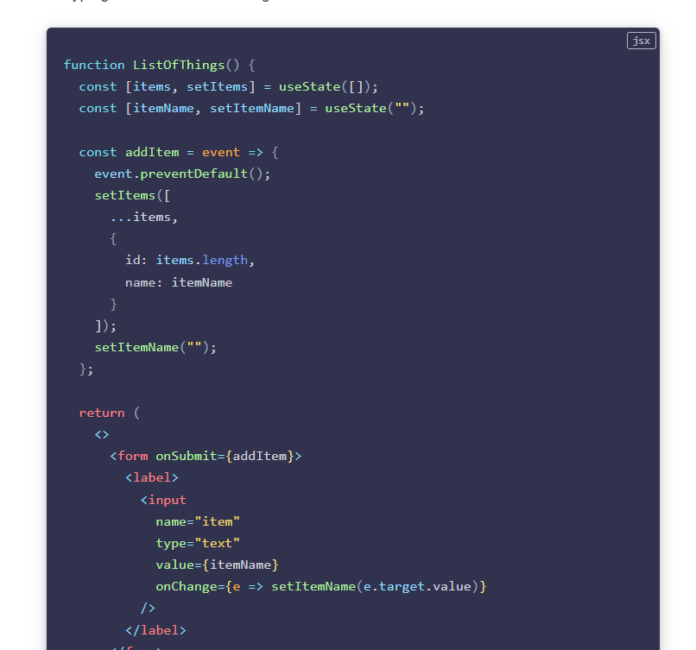

**Topic**: Adding a WEBAPI Call with a Post (Using AXIOS) and adding a record using a complex object with reactjs and object from javascript  
  
After adding the complex form example above, I added a method to my webAPI project.  
Notice the [FromBody] attribute in the webAPI method, this says take content from the “body” of the request (POST)  
The type is of the type in .net (it needs a class) to expect an object with key value pairs

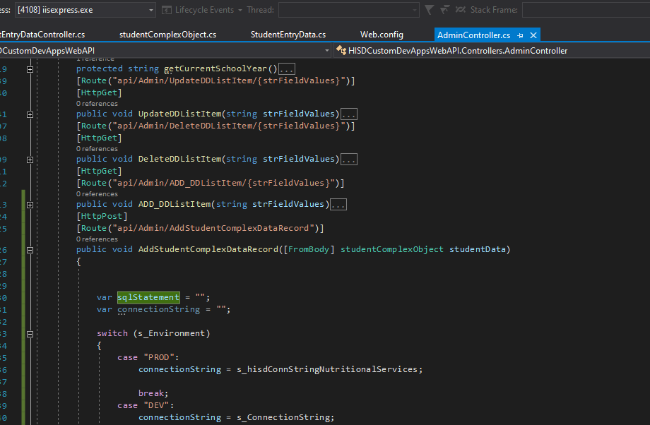  
  
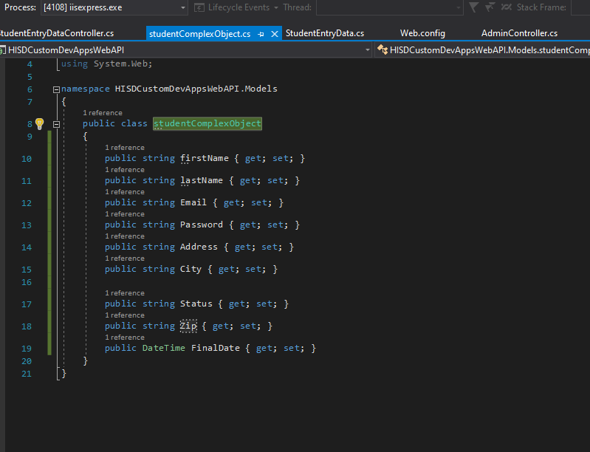  
  
Over on the javascript side:  
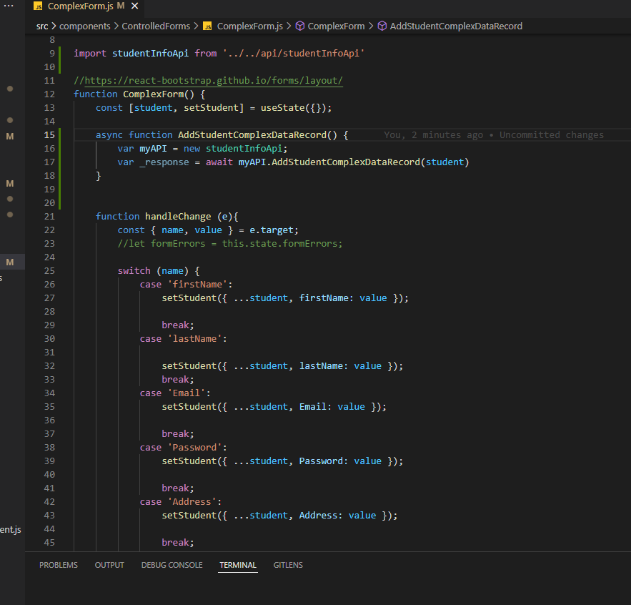  
When we call axios, we do not have to specify the type (i:e application type ‘text/json’)  
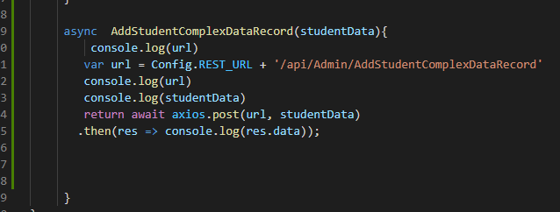  
When I use the useState = ([]), it builds a object with key value pairs that match what the API is expecting  
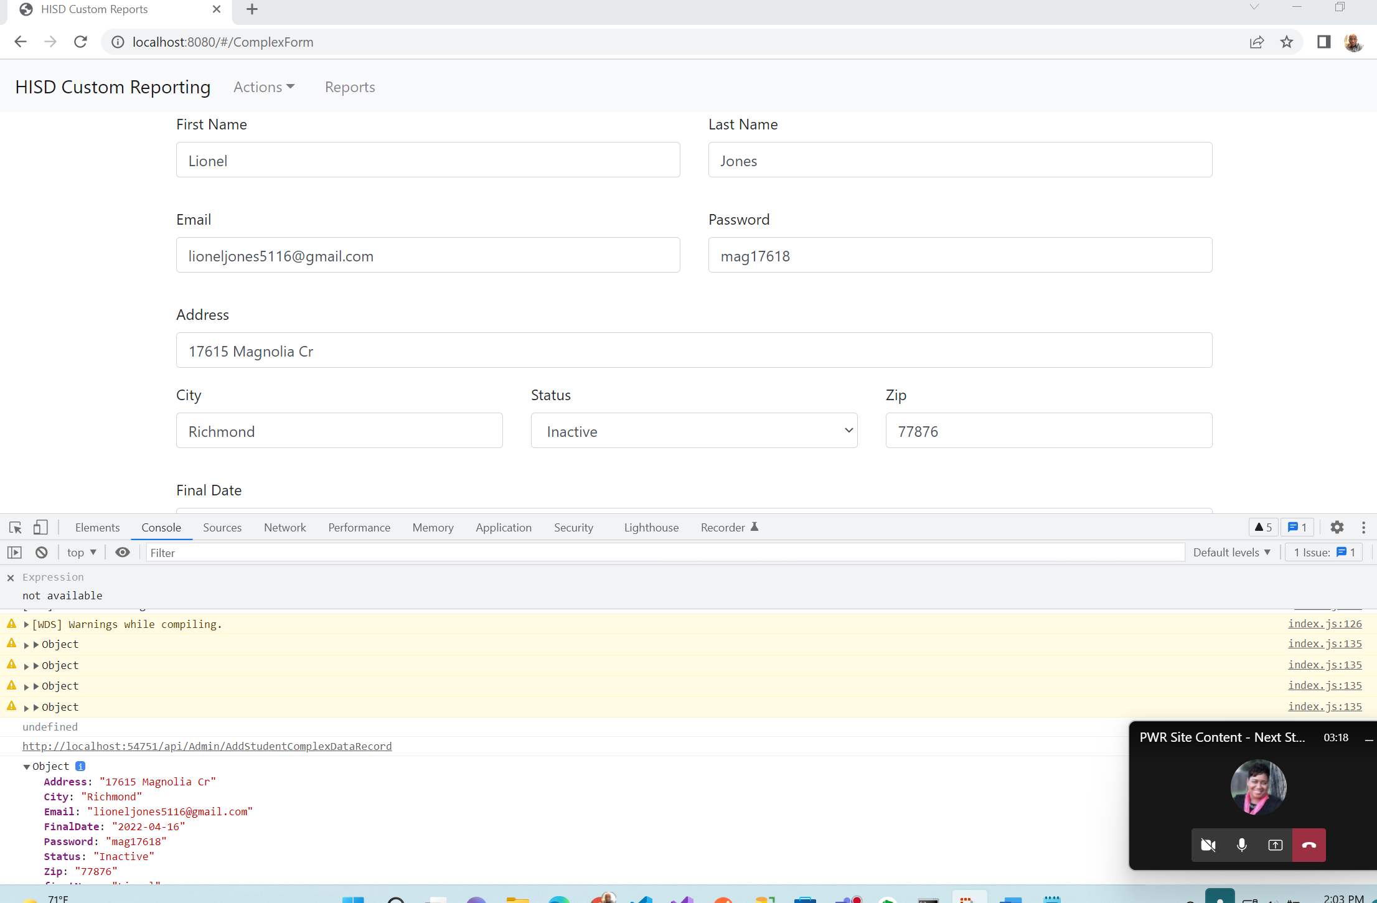  
  
I created a table in sQL:  
 CREATE TABLE [dbo].[studentComplexObject](

[firstName] [nvarchar](100) NULL,

[lastName] [nvarchar](100) NULL,

[Email] [nvarchar](100) NULL,

[Password] [nvarchar](100) NULL,

[Address] [nvarchar](100) NULL,

[City] [nvarchar](100) NULL,

[Status] [nvarchar](100) NULL,

[Zip] [nvarchar](100) NULL,

[FinalDate] [date] NULL

) ON [PRIMARY]

GO

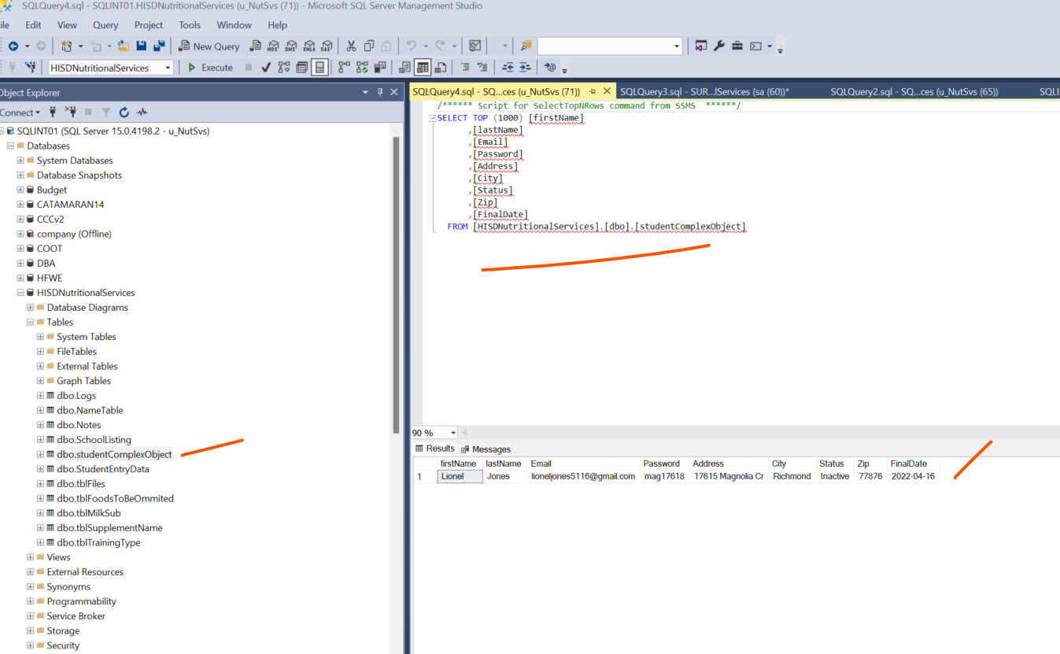  
  
  
  
And it works